What is Energy Worksheet
This worksheet accompanies slide 6 of What is Energy.ppt

Energy transfer (Sankey) diagrams
Create diagrams by cutting out and arranging the labels below.

Electrical | Thermal
Light | Nuclear
Gravitational Potential | Chemical
Kinetic | Elastic  Potential
Sound

Construct diagrams to show the energy transfers in the following:

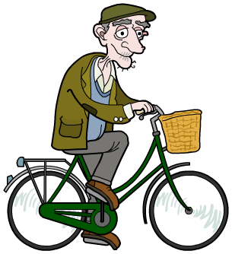

1. Bicycle 2. Sheep



3. Blowdryer 4. Shuttle launch

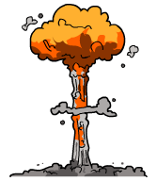

5. Atomic bomb 6. Skydiver

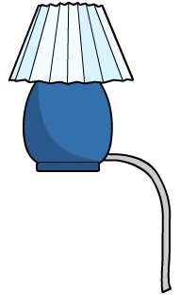
- Consider the energy transfers in this table lamp.

In what form is energy being wasted?
……………………………………………………………………
……………………………………………………………………

- How do you think the energy transfers would be different in a lamp using a more energy efficient light bulb?
……………………………………………………………………………………………
……………………………………………………………………………………………

- Consider the energy transfers in a bike. Is all the energy supplied by the cyclist transferred into useful kinetic energy? How is it wasted?

……………………………………………………………………………………………
……………………………………………………………………………………………
……………………………………………………………………………………………
……………………………………………………………………………………………
……………………………………………………………………………………………

