What are Circuits Worksheet
This worksheet accompanies slide 4 of What Are Circuits.ppt

What is an electrical circuit?
Use this role play to explore the concepts behind electrical circuits.

Role play
Work in a group of 6-10 students.
Each student must take on one of the following roles:
1 student is the cell
1 student is the bulb
The remaining students are electrons.
At the start of the role play, the cell should hold a number of “packets of energy.” You will need at least twice as many as the number of electrons in your group.

Now arrange yourselves so that you best represent a simple circuit containing a cell and a bulb.
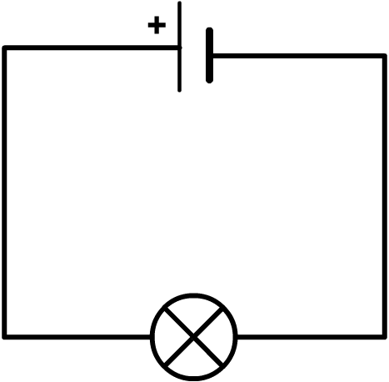

You need to decide the following:

- Where will the cell stand?
- Where will the bulb stand?
- What path will the electrons take?
- What will happen to the packets of energy?
Now perform your role play.

Questions:

- What happens to the energy when it reaches the bulb?
……………………………………………………………………………………………
……………………………………………………………………………………………

- Electrons in the circuit start moving at the same time and travel at the same speed.
How could you alter your role play to show this?
……………………………………………………………………………………………
……………………………………………………………………………………………
……………………………………………………………………………………………
……………………………………………………………………………………………

- What would happen if the electrons were blocked from returning to the cell?
……………………………………………………………………………………………
……………………………………………………………………………………………
……………………………………………………………………………………………
