Uses of Electromagnets Worksheet
This worksheet accompanies slide 3 of Uses of Electromagnets.ppt

How does an electric bell work?
Work in pairs to explain the mechanism for an electric bell.

In your pair, decide who will be the ‘teacher’ and who will be the ‘learner.’

The ‘teacher’ should go to the front of the class, where your instructor will explain how the bell works.

When you return to your partner, use the images below to explain how the bell works. You may want to cut them out and move them around if this will help your explanation.


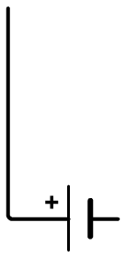




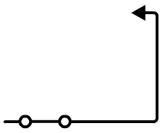

The ‘learner’ should now draw a diagram of an electric bell. Make sure that all the parts are labeled with the correct names.

INSTRUCTOR’S SHEET

BELL
ARMATURE
HAMMER
CONTACT
ELECTROMAGNET
BATTERY

