Types of Variation Worksheet
This worksheet accompanies slide 9 of Types of Variation.ppt

Is there variation within your class?
Complete the activities described below.
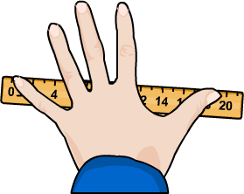

Your hand span width is the distance between
the end of your thumb and the end of your
little finger when you stretch your hand
open as far as possible.

Measure your hand span width and write it here: …………………mm
Now collect the span widths for every student in your class. Write them in the boxes below.

Now figure out how many students there are in each of the following groups using tally marks:

hand span width (mm) | no. of students
100–120
121–140
141–160
161–180
181–200
201–210
211–220
1. Now plot these data as a frequency graph.

2. What does your graph show?

……………………………..………………………………………..……………………………………

……………………………..………………………………………..……………………………………

……………………………..………………………………………..……………………………………

3. Is hand span width a continuous or discontinuous characteristic?

……………………………..………………………………………..……………………………………

4. What factors affect your hand span width?

……………………………..………………………………………..……………………………………

……………………………..………………………………………..……………………………………

