Tsunami Case Study Worksheet
This worksheet accompanies slide 5 of Tsunami Case Study.ppt

1. On what date did the Indian Ocean earthquake occur? At what time did it strike?
____________________________________________________________________________________________________________________________________________________________________
__________________________________________________________________________________

2. What was the magnitude of the earthquake?
____________________________________________________________________________________________________________________________________________________________________
__________________________________________________________________________________

3. What tectonic plates were involved in the earthquake? Can you label them on the map below? Also label the epicenter and name the countries shown on the map.
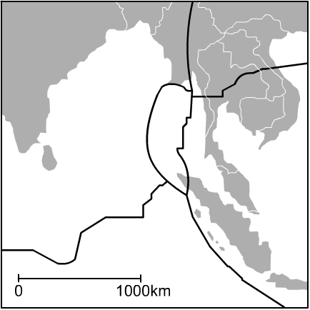

4. Write a description of how fast the tsunami moved in open water and how tall it became as it approached the shore lines of the countries surrounding the Indian Ocean.
________________________________________________________________________________________________________________________________________________________________________________________________________________________________________________________________________________________________________________________________________________________________________________________________________________________________________________________________________________________________________________________________________________________________________________________________________________________________________________________________________________
____________________________________________________________________________________________________________________________________________________________________
____________________________________________________________________________________________________________________________________________________________________

5. Use bullet points to outline some of the effects of the tsunami wave, e.g. boats were carried inland.

●

●

●

●

●

●

●

●

