Tornados Worksheet
This worksheet accompanies Tornados.ppt

- Indicate on the map where tornados are most likely to occur.

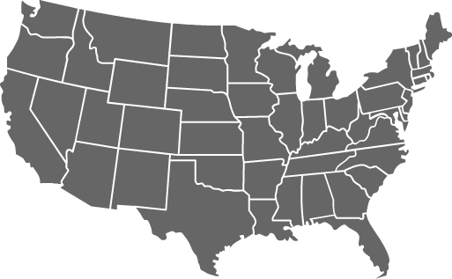

- How powerful are the most powerful tornados compared with hurricanes like Hurricane Katrina?
______________________________________________________________________
______________________________________________________________________
______________________________________________________________________

- What is the name of the scale used to classify tornados? _________________________________

- What type of cloud forms a tornado when it touches the ground? __________________________

- Do tornados ever affect your state or region? If you find they do, write down the details of a particular event below. ___________________________________________________________________
___________________________________________________________________
___________________________________________________________________
___________________________________________________________________
_________________________________________________________

