The pH Scale Worksheet One
This worksheet accompanies slide 4 of The pH Scale.ppt

Using universal indicator

Instructions:
- Prepare a range of solutions from everyday sources, such as oranges, milk etc.
- Carefully cut some pH paper into small squares, and then place them onto a tile.
- Use a glass rod to transfer one drop of each solution onto one of the squares of pH paper.
- Observe the color change and record it in the results table below.

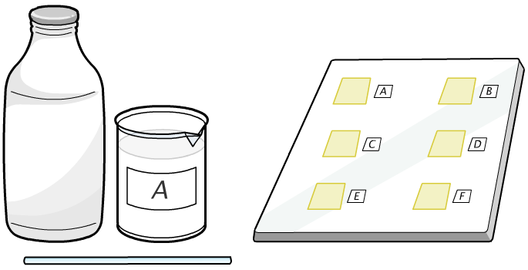

Substance |  | Color of pH paper | pH | Acid, alkali or neutral? | Strong or weak?
A | e.g. milk
B
C
D
E
F

Questions:
1. Which substances were the strongest acids? …………………………………………..…..………...……

2. Which substances were the strongest alkalis? ……………………………………………..………..……

3. Which substances were neutral? ……………………………………………………..……..…………….

4. Which substances are too acidic or alkaline to eat? ....................................................................................
....................................................................................................................................................................................................................................................................................................................................................
..........................................................................................................................................................................

The pH Scale Worksheet Two
This worksheet accompanies slide 7 of The pH Scale.ppt

Testing the pH of soils

- Rewrite these steps for soil testing in the correct order:
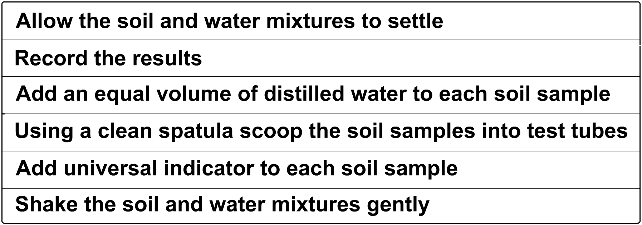

Step 1 .........................................................................................................................................................
Step 2 .........................................................................................................................................................
Step 3 .........................................................................................................................................................
Step 4 .........................................................................................................................................................
Step 5 .........................................................................................................................................................
Step 6 .........................................................................................................................................................

- What improvements could you make to this soil testing technique? For example, would the results be easier to read if the soil were filtered before adding the indicator? Would a pH meter be more reliable than litmus?

…………………………………………………………………………………………………………......
…………………………………………………………………………………………………………......
…………………………………………………………………………………………………………......
…………………………………………………………………………………………………………......
…………………………………………………………………………………………………………......
- The map below shows the different acidities of the soil in a yard. Write down the names of the plants from the list that will grow best in each of the four different areas.

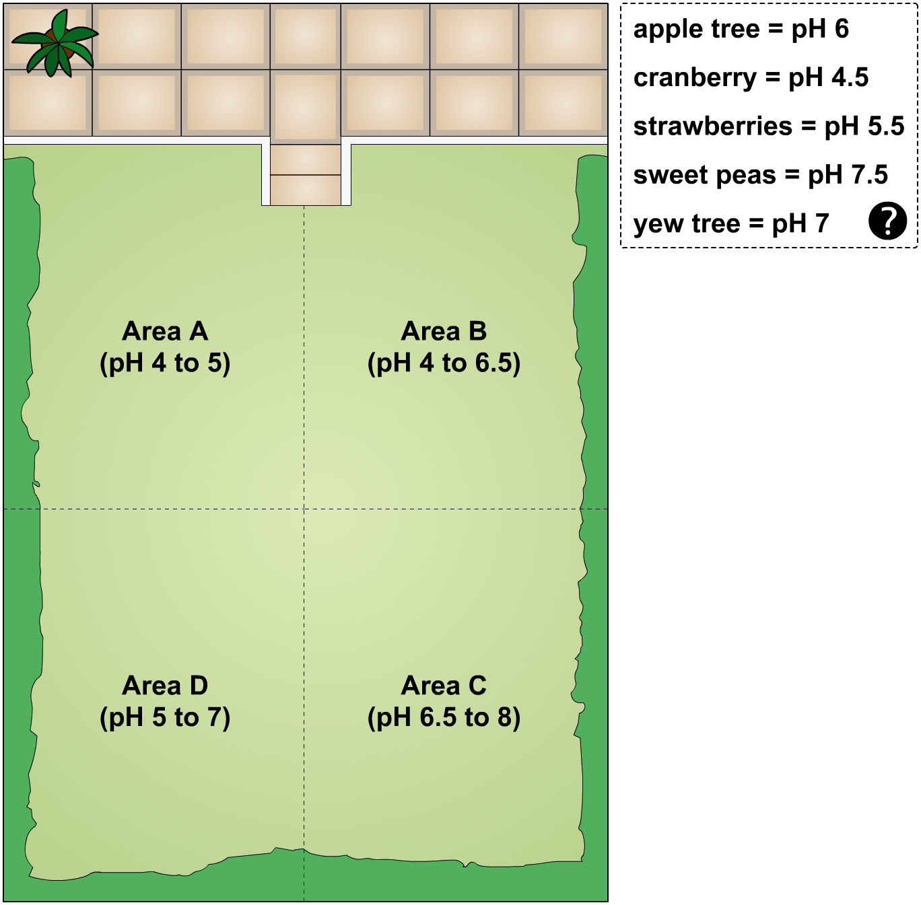

Area A: ............................................................................................................................................................
Area B: ............................................................................................................................................................
Area C: ............................................................................................................................................................
Area D: ............................................................................................................................................................

