The Solar System Worksheet
This worksheet accompanies slide 6 of The Solar System.ppt

Planet Postcards
What do you think a postcard from another planet might look like?

- Circle a planet from the following list that you would like to know more about:

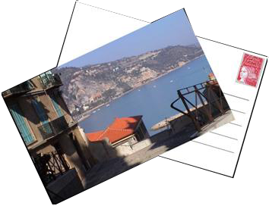
Mercury
Venus
Mars
Saturn
Jupiter
Uranus
Neptune

- Using books or any other sources of information, find out at least five facts about that planet.

- Design a postcard from that planet. You need to draw a front to the postcard that suits your planet. Think about:
  - what the surface of the planet might look like
  - what the sky looks like
  - how the Sun appears
  - what other celestial bodies you can see.

- Write a message on the back of your postcard to someone on Earth, as if you are visiting the planet you have chosen. You must use your five facts in your postcard.
Think about:
  - the atmosphere on your planet – can you breathe?
  - the temperature
  - the amount of sunlight
  - whether there are any life forms on the planet
  - whether there is any evidence of human exploration.

You can cut out this template and draw on the back if you choose.

