The Nervous System Worksheet
This worksheet accompanies slide 3 of The Nervous System.ppt

What’s your reaction time?
Measure your reaction time and answer the questions below.

Fast responses are useful because they can help you to react to situations quickly.
You can test how fast your reflexes are by measuring your reaction time.

Measure your reaction time using a falling ruler.
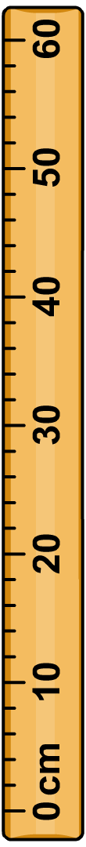
1. Extend your arm over the edge of a table and have a partner hold a ruler between your fingers at the 0 cm mark.

2. When your partner drops the ruler, catch it between your fingers and thumb as quickly as possible.

3. Repeat the test 10 times, recording your results in the table below, and calculate the mean (average) distance. Then convert the distance into a reaction time.

attempt | distance dropped (cm)
1
2
3
4
5
6
7
8
9
10
average

1. What is your reaction time? Circle the value that is closest to your reaction time.

distance on ruler time distance on ruler time
1 cm 0.05 sec
2 cm 0.06 sec
3 cm 0.07 sec
4 cm 0.08 sec
5 cm 0.09 sec
6 cm 0.10 sec
7 cm 0.12 sec
8 cm 0.13 sec
9 cm 0.14 sec
10 cm 0.14 sec
11 cm 0.14 sec
12 cm 0.15 sec
13 cm 0.16 sec
14 cm 0.16 sec
15 cm 0.17 sec
16 cm 0.18 sec
17 cm 0.19 sec
18 cm 0.19 sec
19 cm 0.20 sec
20 cm 0.21 sec
21 cm 0.21 sec
22 cm 0.21 sec
23 cm 0.22 sec
24 cm 0.22 sec
25 cm 0.23 sec
26 cm 0.23 sec
27 cm 0.23 sec
28 cm 0.24 sec
29 cm 0.24 sec
30.cm 0.25 sec

2. Does your reaction time increase with practice? Why do you think this is?

……………………………..………………………………………..……………………………………

……………………………..………………………………………..……………………………………

……………………………..………………………………………..……………………………………

……………………………..………………………………………..……………………………………

Athletes often need quick reflexes. They can improve the speed of their reflex by practicing their sport.

3. Which sports require fast reflexes?

……………………………..………………………………………..……………………………………

……………………………..………………………………………..……………………………………

