The Ear and Hearing Worksheet
This worksheet accompanies slide 3 of The Ear and Hearing.ppt

What are the different parts of the ear?
Work in pairs to complete this activity.

One student should have this worksheet and sit facing away from the whiteboard.
Their partner should look at the board where your teacher will display slide 3 from the presentation.

The student facing the board should describe to their partner what each part of the ear looks like so that they can label the diagram correctly.

………….………….………

………….………….………

………….………….………

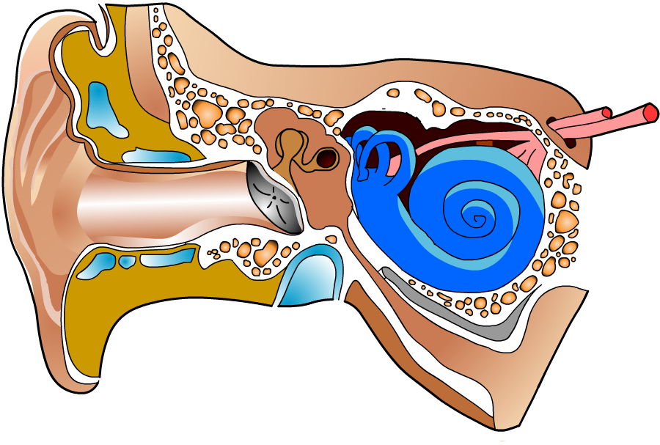
………….………….………

………….………….………

………….………….………

As a pair, write brief descriptions of what each part of the ear does, without looking at the board.

Outer ear …………………………………………………………………………………..
……………..………………………………………………………………………………...

Ear canal ………………………………………………………………………….………..
……………..………………………………………………………………………………...

Eardrum …………………………………………………………………………….……...
……………..………………………………………………………………………………...

Ossicles ……………………………………………………………………………………..
……………..………………………………………………………………………………...

Cochlea ……………………………………………………………………………………..
……………..………………………………………………………………………………...

Auditory nerve ……………………………………………………………………………..
……………..………………………………………………………………………………...

