Speed of Sound Worksheet
This worksheet accompanies slide 11 of Speed of Sound.ppt

Design an experiment to measure the speed of sound
Use the apparatus illustrated on slide 11 to set up an experiment to test the speed of sound using echoes. The apparatus is shown again here:
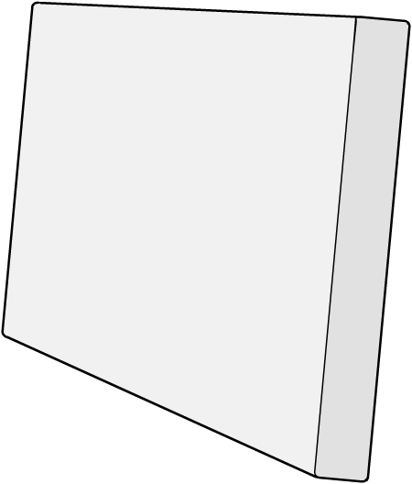
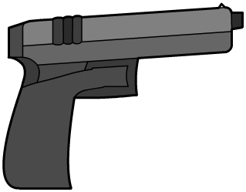

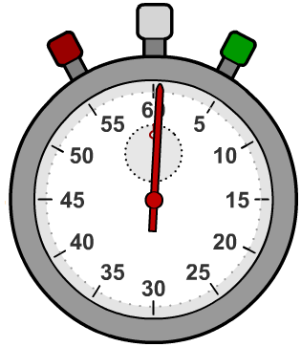


stopwatch
clapper board

hard,
flat surface

starting pistol

Draw a diagram of your experiment in the box below:

Describe the methodology for your experiment:

…………………………………………………………………………………………………………………………………………………………………………………….……………………………………………………………………………………………………………………………………………………………………………………………………………………………………………………………………………………………….……………………………………………………………………………………………………………………………………………………………………………………………………………………………………………………………………………………………….…………………………………………………………………………………………………………
Record your results in the table:

Distance | Time | Speed
- Calculate the average of your results for the speed of sound in air.
…………………………………………………………………………………………………………………………………………………………………………………….…..……………………………………………………………………………………………

- How do your calculations compare with the actual speed of sound in air?

…………………………………………………………………………………………………………………………………………………………………………………….…...

- How did you ensure that your result was as reliable as possible?
…………………………………………………………………………………………………………………………………………………………………………………….…..……………………………………………………………………………………………

- How do you think increasing the distance used in the experiment would affect the accuracy of the result?

………………………………………………………………………………………………………………………………………………………………………………………………………………………………………………………………………………………

- Could you improve the experiment in any way to make it even more accurate?
…………………………………………………………………………………………………………………………………………………………………………………….…..……………………………………………………………………………………………

