Solutions Worksheet
This worksheet accompanies slide 12 of Solutions.ppt

Does temperature affect solubility?

You are going to plan an experiment to find out whether the solubility of a solute changes with temperature. Your solute is sugar and your solvent is tap water.

There are a number of questions to think about before you start:
- How many different temperatures should you test?
- How much water are you going to use? (What difference might using lots of water make?)
- How will you decide when the solution has become saturated?
- How will you measure the amount of solute you have added?
- How will you make sure that the experiment is a fair test?

- Choose what you need from the following pieces of apparatus:

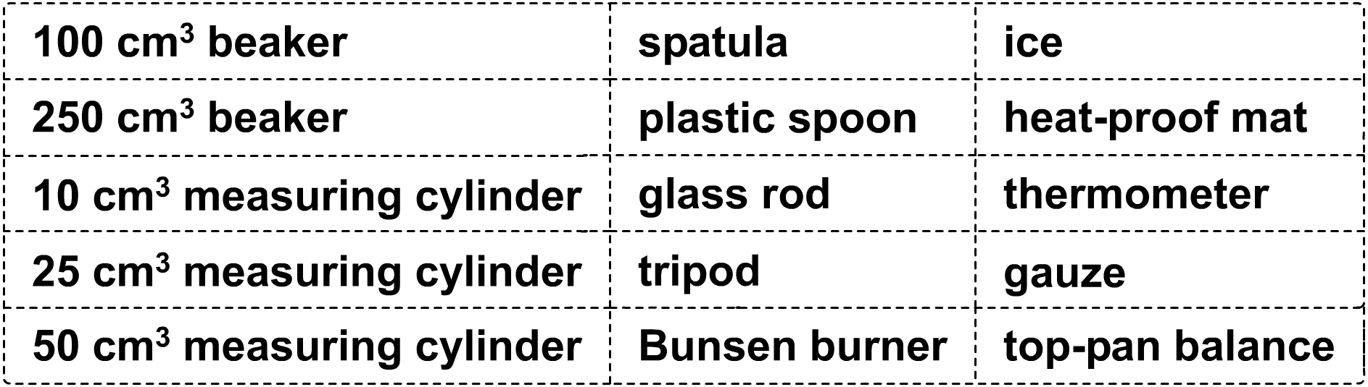

- Set up your chosen apparatus. Draw a diagram showing the final arrangement of the apparatus in the space below. Remember to label the apparatus clearly.

- Carry out your experiment., then write a step-by-step method to explain what you did:

…………………………………………………………………………………………………………......
…………………………………………………………………………………………………………......
…………………………………………………………………………………………………………......
…………………………………………………………………………………………………………......
…………………………………………………………………………………………………………......
…………………………………………………………………………………………………………......
…………………………………………………………………………………………………………......
…………………………………………………………………………………………………………......
…………………………………………………………………………………………………………......
…………………………………………………………………………………………………………......
…………………………………………………………………………………………………………......
…………………………………………………………………………………………………………......

- Draw a table to show your results in the space below. Don’t forget to include the units in the column headings.

- Using a sheet of graph paper, plot your results in a line graph, and draw a smooth line of best fit through the results. Do your results show a pattern? Briefly describe the pattern:

…………………………………………………………………………………………………………......
…………………………………………………………………………………………………………......
…………………………………………………………………………………………………………......

- Write down a sentence explaining what you think solubility means:

…………………………………………………………………………………………………………......
…………………………………………………………………………………………………………......

- What units do you think solubility might be measured in? …………………………......……......……..

- Show how the solute (sugar) and solvent (water) particles were arranged in the solution by drawing a diagram in the space below:

- What could you do to check the results of your experiment?

…………………………………………………………………………………………………………......
…………………………………………………………………………………………………………......
…………………………………………………………………………………………………………......



