Separating Mixtures Worksheet
This worksheet accompanies slide 9 of Separating Mixtures.ppt

The Clean Water Challenge?
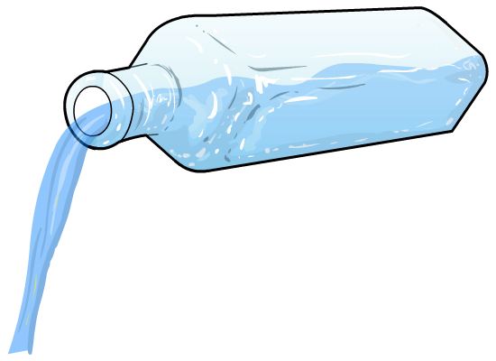
Can you make clean water from dirty salty water?

Imagine you have been stranded on a desert island and there is no fresh water. You need to make some clean and drinkable water from seawater before you die of thirst!

As you explore the island, you come across a fisherman’s hut among the palm trees, in which there are some pieces of equipment that might prove useful:

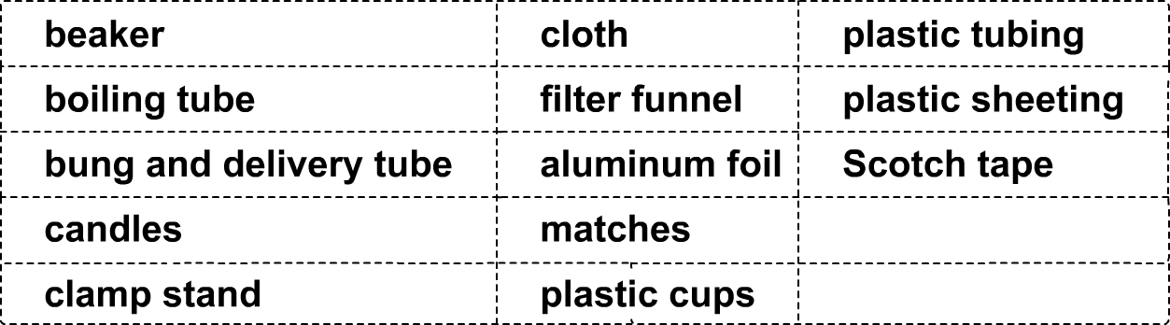

- What is the name of the method by which liquids are separated from a mixture? …………...…………

- Think carefully about which pieces of the equipment that you found could be used, then show how you would assemble the equipment by drawing a diagram in the space below:

