Selecting Characteristics Worksheet One
This worksheet accompanies slide 3 of Selecting Characteristics.ppt

Selective breeding dogs
Answer the questions below…

Today there are hundreds of different breeds of domestic dogs around the world. They are all descended from the wolf. Below are picture of three modern dog breeds: a Dalmatian, a St. Bernard and a Border Terrier, and their ancestor: the wolf.
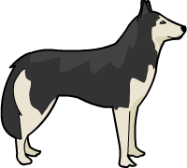
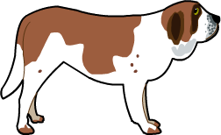
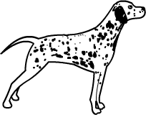

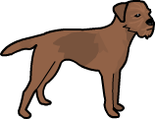

Wolf
St. Bernard
Dalmatian
Border Terrier

1. A long time ago, humans developed breeds of domestic dogs by mating wild wolves together until the desired characteristics were produced. What is the name of this type of breeding?

……………………………..………………………………………..……………………………………

2. Which features do you think humans wanted to breed out of the wild wolf? Circle the correct answer.

pointed nose
aggressive behavior
small feet
good eyesight

3. The St. Bernard was bred to help people in the Alps. They were used to guide people along snow-covered paths and to help in mountain rescue. What features do you think people wanted to breed into the St. Bernard?

……………………………..………………………………………..……………………………………

……………………………..………………………………………..……………………………………

4. The Border Terrier was bred to help people hunt small mammals in Britain.
What features do you think people wanted to breed into the Border Terrier?

……………………………..………………………………………..……………………………………

……………………………..………………………………………..……………………………………

Selecting Characteristics Worksheet Two
This worksheet accompanies slide 8 of Variation.ppt

Genetic engineering debate
In the activity below you will be having a debate about GM crops.

Genetic engineering is a very controversial topic. Many people believe that genetically modified (GM) crops have the potential to provide more food for those in need. Others think the risk to the environment is too high.

There are plans to grow a trial field of GM crops in your area.
Split into groups of four. Each person in the group should be one of the following people:
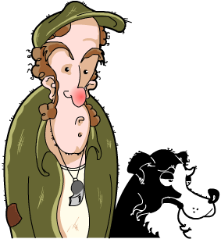
Farmer
Your land is being used to grow GM crops for a trial. You think they are as safe as they can be and that the only way to measure the risk is to grow them. You think that the potential
to produce high crop yields outweighs the possible risks.

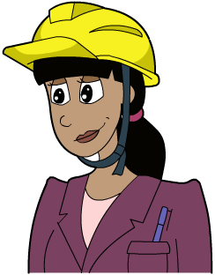
Environmentalist
You think that, in reality, GM crops would simply allow big companies to make more money, not help people in need. You’re concerned that the GM crops would be produced by rich companies and sold to the developing world.



Charity worker
You have recently worked in developing countries that
have suffered from food shortages. You believe that growing GM crops could prevent this, because crops could be modified to contain extra vitamins and minerals. You believe that if the trials are carried out with the maximum safety precautions then it is a good move in the right direction.

Scientist
You are concerned that the risk of cross-contamination is too high – this could lead to the new genetic material being incorporated into natural plants. Once a trial has begun there will be no going back, since the environment will have been exposed to these GM organisms. You think that the harmful effects of GM crops cannot be measured over a short period of time, but the full effects will only become evident after a matter of years.


1. In your group, discuss, in character, the advantages and disadvantages of growing GM crops.

2. As your character, discuss whether you think the government should be growing GM crops as trials to assess their suitability and measure their impact.

Using the issues raised in your debate, fill in the table below outlining the advantages and disadvantages of growing GM crops.

Advantages | Disadvantages

Has this debate changed your opinion about genetic engineering?

……………………………..………………………………………..……………………………………

……………………………..………………………………………..……………………………………

……………………………..………………………………………..……………………………………

