Respiration and the Circulatory System Worksheet One
This worksheet accompanies slide 2 of Respiration and the Circulatory System.ppt

Circulation
Look at the diagram and answer the questions below.

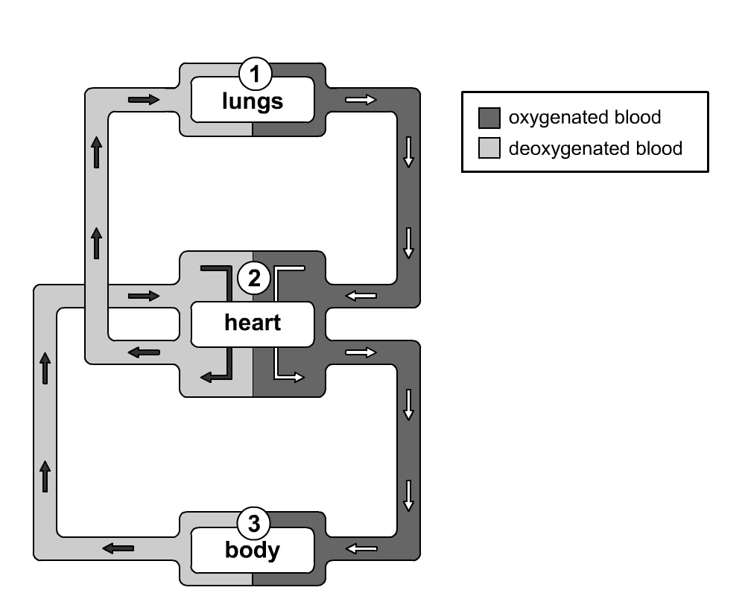

1. At which point in the diagram (1, 2 or 3) is…

…oxygen used up? …………..………

…oxygen added to the blood? …………………

2. What causes blood to move around the body?

……………………………………………………………………………………………….……………

3. Fill in the gaps in the equation for aerobic respiration.

…..…………………………………… + glucose = ……………………………..…………… + water

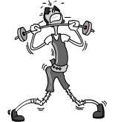
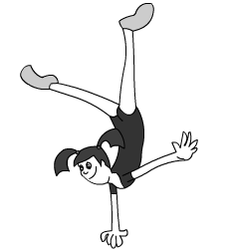
Respiration and the Circulatory System Worksheet Two
This worksheet accompanies slide 7 of Respiration and the Circulatory System.ppt

What happens when you exercise?
Complete the activities below.

Exercise causes your heart rate to change. You can measure your heart rate by taking your pulse. Complete the activity below to see how much your pulse rate changes.

Practical

Sit down and relax for 2 minutes. Take your pulse for 30 seconds.
Calculate how many times your heart would beat in a minute.
Write the answer here:

resting pulse: ……………… beats per minute

Now walk for 2 minutes. Stop. Take your pulse for 30 seconds.
Calculate how many times your heart would beat in a minute.
Write the answer here:

pulse after walking: ……………… beats per minute

Now jog for 2 minutes. Stop. Take your pulse for 30 seconds.
Calculate how many times your heart would beat in a minute.
Write the answer here:

pulse after jogging: ……………… beats per minute

Plot your results using the graph paper.



Questions

1. What happened to your pulse rate as you exercised more?

…………………………………………………………………………..……………………..………

2. Why do you think this happened?

…………………………………………………………………………………....…..…………………

…………..………………………………………………………………………….……………………

