Renewable Energy Worksheet
This worksheet accompanies slide 8 of Renewable Energy.ppt

Energy resources trump cards
Cut out the cards below and compare the strengths and weaknesses of each resource.

Each property is scored out of 10, with 10 being the best, and 1 being the worst.

Nuclear Power

Years left 3
Safe for people 1
Safe for environment 7
Cost effective 3
Energy produced 9

Solar Power

Years left 10
Safe for people 9
Safe for environment 8
Cost effective 3
Energy produced 4


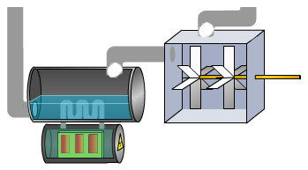

Geothermal Power

Years left 10
Safe for people 5
Safe for environment 8
Cost effective 3
Energy produced 3

Coal Power

Years left 4
Safe for people 5
Safe for environment 2
Cost effective 7
Energy produced 9

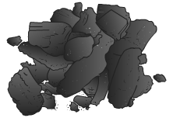
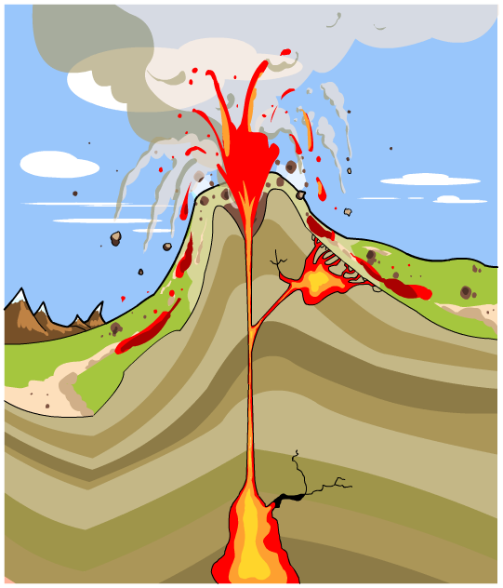

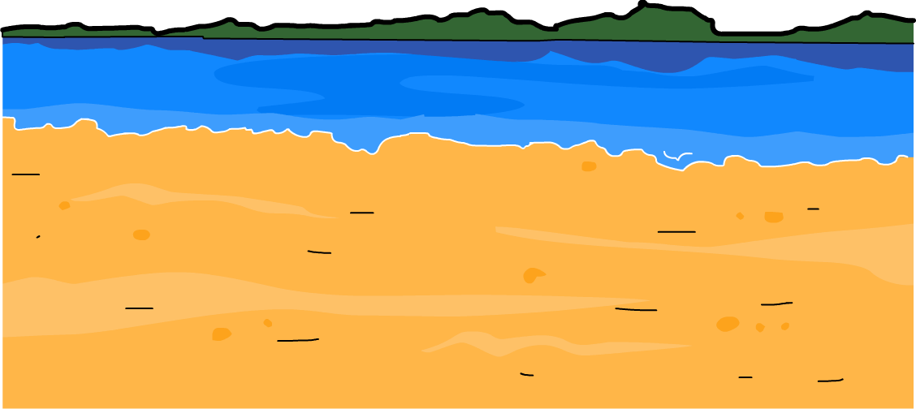
Tidal Power

Years left 10
Safe for people 8
Safe for environment 7
Cost effective 4
Energy produced 5

Wind Power

Years left 10
Safe for people 8
Safe for environment 7
Cost effective 2
Energy produced 4

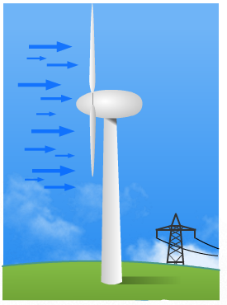

Oil Power

Years left 2
Safe for people 3
Safe for environment 2
Cost effective 6
Energy produced 9

Natural Gas Power

Years left 2
Safe for people 3
Safe for environment 2
Cost effective 7
Energy produced 9

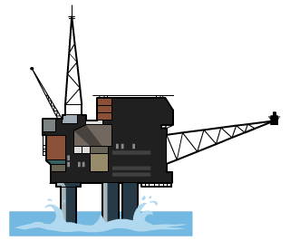


Hydroelectric Power

Years left 10
Safe for people 7
Safe for environment 7
Cost effective 5
Energy produced 7

Wave Power

Years left 10
Safe for people 7
Safe for environment 7
Cost effective 5
Energy produced 2

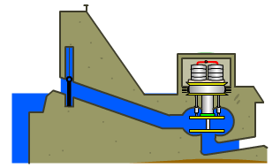
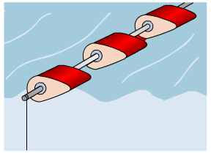

Biomass Power

Years left 10
Safe for people 4
Safe for environment 3
Cost effective 8
Energy produced 7



- Sort the cards into renewable and nonrenewable energy resources.
What areas do renewable energy resources score best in?

……………………………………………………………………………………………
……………………………………………………………………………………………
……………………………………………………………………………………………
What areas do nonrenewable energy resources score best in?

……………………………………………………………………………………………
……………………………………………………………………………………………
……………………………………………………………………………………………

- Which energy resource scores the highest total score?

……………………………………………………………………………………………
Can you think of any problems with this energy resource that are not mentioned on the card?

……………………………………………………………………………………………
……………………………………………………………………………………………
……………………………………………………………………………………………

- Which energy resource do you think the government should invest in to provide the United States with energy for the next 100 years? Explain your answer.

……………………………………………………………………………………………
……………………………………………………………………………………………
……………………………………………………………………………………………
……………………………………………………………………………………………
……………………………………………………………………………………………

