Refraction Worksheet
This worksheet accompanies slide 3 of Refraction.ppt

Refraction in a glass block

Place a glass block in the center of a sheet of paper and draw around it. Draw a normal through the center of the outline and shine a beam of light at the point on the edge of the block where it touches the normal.

- Label the diagram below and mark the angle of incidence and angle of refraction where the beam enters the glass block.

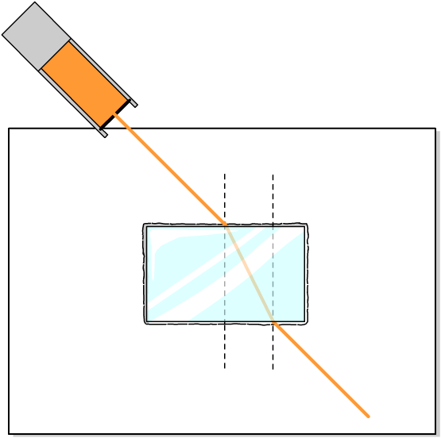

……………………………….

……………………………….

……………………………….

……………………………….

Set up the experiment with the light beam hitting the block at angles of 60°, 30° and 0°. Use your results to complete the following diagrams. Make sure you mark the angles of incidence and refraction for the light entering and leaving the block.
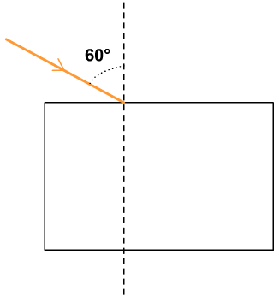
2.

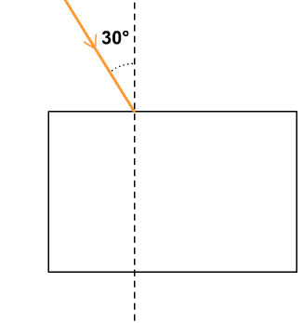
3.

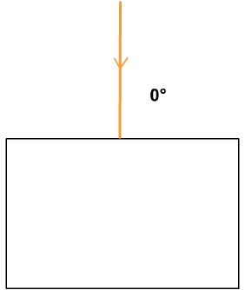
4.

- Record your results in this table:

entering block |  | exiting block
angle of incidence | angle of refraction | angle of incidence | angle of refraction
60°

30°

0°

- Does light travel faster through air or glass?
………………………………………………………………………………………………………………

- a) What is the relationship between the angle of incidence as the light enters the block and the
angle of refraction as the light leaves the block?

………………………………………………………………………………………………………………………………………………………………………………………………………………………………
b) Can you explain why this is the case?
………………………………………………………………………………………………………………………………………………………………………………………………………………………………
………………………………………………………………………………………………………………

- How do you think the results of the experiment might have differed if a material denser than glass had been used?

……………………………………………………………………………………………………………………………………………………………………………………………………………………………………………………………………………………………………………………………………………….

