Reflection Worksheet
This worksheet accompanies slide 3 of Reflection.ppt

Reading in mirrors

Cut along the dotted lines to create a word card. The activity should be carried out in pairs, and a mirror and a stopwatch are needed. Both students should stand facing a mirror, one behind the other. The student furthest from the mirror holds up the word card and times how long it takes the other to read all 10 words out loud by looking at them in the mirror. Record the results and compare with the rest of the class.

horse | refract
banana | radish
reflect | force
incident | gravity
eyeball | fridge

- Why would it be an unfair test if you now swapped roles with your partner and tried the test again?

………………………………………………………………………………………………
………………………………………………………………………………………………

- Why was it so difficult to read the words in the mirror? What did you notice about how they appeared?

………………………………………………………………………………………………
………………………………………………………………………………………………
………………………………………………………………………………………………

- What do you think would happen if you used a second mirror and tried reading the words after they had been reflected in both?

………………………………………………………………………………………………
………………………………………………………………………………………………
………………………………………………………………………………………………
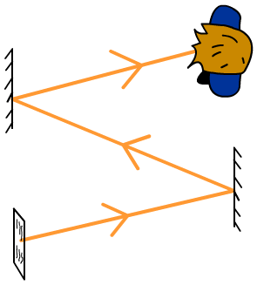

mirror
words

