Pyramids of Numbers and Biomass Worksheet
This worksheet accompanies slide 7 of Pyramids of Numbers and Biomass.ppt

What are the feeding relationships in a kelp forest?
Read the information provided and answer the following questions.

Kelp is a species of large seaweed that grows in underwater forests off the Pacific coast of North America. Below is a simple food chain showing some of the organisms that live in the kelp forest habitat:

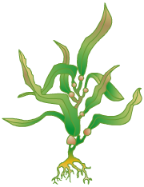

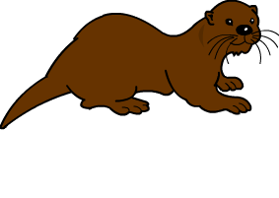
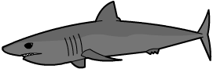

kelp
sea urchin
otter
shark

1. What do the arrows in the food chain show?

……………………………………………………………………………………………….……………

2. What is the name given to organisms like the kelp? Circle the correct answer.

producer consumer carnivore omnivore

3. What might happen if the sea urchin population died out in the kelp forest?
Below, indicate whether you think each animal population would go up or down.

kelp
increase ↑
decrease ↑

increase ↑
decrease ↑
otter

increase ↑
decrease ↑
shark

4. Label the pyramid of biomass below to show which level represents which animal in this food chain.

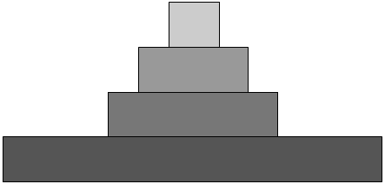

5. What is biomass?

……………………………………………………………………………………………….……………

……………………………………………………………………………………………….……………

6. Why does the amount of biomass available at each level decrease as you go up a food chain?

……………………………………………………………………………………………….……………

……………………………………………………………………………………………….……………

7. Kelp forests support a wide variety of life. In reality there are several other feeding relationships involved in this habitat. Using books and the Internet, draw a food web for the kelp forest.
Use kelp, sea urchins, otters and sharks in your food web, as well as 3 or 4 other species.

