Precipitation Worksheet
This worksheet accompanies slide 9 of Precipitation.ppt

- Provide a description of the process involved in the formation of convectional rain.

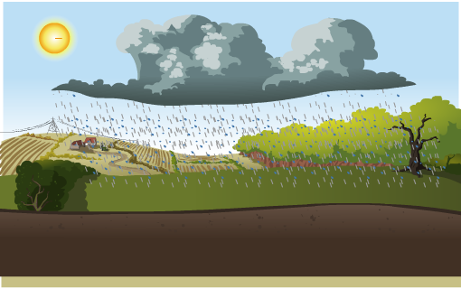
Be sure to mention the following:
- how is it formed?
- where is it commonly seen?
- what features are associated with it?

________________________________________________________________________________________________________________________________________________________________________________________________________________________________________________________________________________________________________________________________________________________________________________________________________________________________________________________________________________________________________________________________________________________________________________________________________________________________________________________________________________________________________________________________________________________________________________________________________________________________________________________________________________________________________________________________________________________________________________________________________________________________________________________________________________________________________________________________________________________________________________________________________________________________________________________________________________________________________________________________________________________________________________________________________________________________________________________________________________________________

- Provide a description of the process involved in the formation of frontal rain.

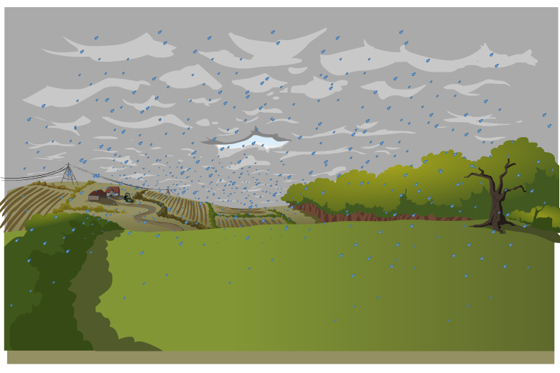
Be sure to mention the following:
- how is it formed?
- where is it commonly seen?
- what features are associated with it?

________________________________________________________________________________________________________________________________________________________________________________________________________________________________________________________________________________________________________________________________________________________________________________________________________________________________________________________________________________________________________________________________________________________________________________________________________________________________________________________________________________________________________________________________________________________________________________________________________________________________________________________________________________________________________________________________________________________________________________________________________________________________________________________________________________________________________________________________________________________________________________________________________________________________________________________________________________________________________________________________________________________________________________________________________________

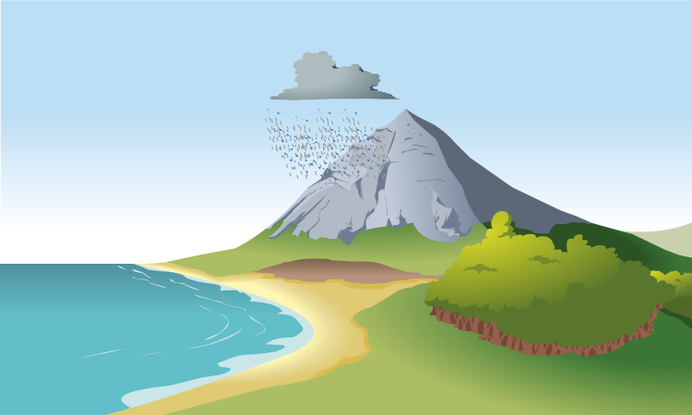
- Provide a description of the process involved in the formation of relief rain.

Be sure to mention the following:
- how is it formed?
- where is it commonly seen?
- what features are associated with it?

________________________________________________________________________________________________________________________________________________________________________________________________________________________________________________________________________________________________________________________________________________________________________________________________________________________________________________________________________________________________________________________________________________________________________________________________________________________________________________________________________________________________________________________________________________________________________________________________________________________________________________________________________________________________________________________________________________________________________________________________________________________________________________________________________________________________________________________________________________________________________________________________________________________________________________________________________________________________________________________________________________________________________________________________________________________________________________________________________________________________

