Plate Boundaries Worksheet One
This worksheet accompanies Plate Boundaries.ppt

- Explain how divergent plates are pushed apart. Use your knowledge of convection currents to help you explain your answer. You may also wish to create drawings or arrows in the box below.
________________________________________________________________________________________________________________________________________________________________________________________________________________________________________________________________________
____________________________________________________________________________________________________________________________________________________________________________________________________________________
________________________________________________________________________________
________________________________________________________________________________
________________________________________________________________________________

- Describe and illustrate what happens when convergent plates are pushed together:
________________________________________________________________________________________________________________________________________________________________________________________________________________________________________________________________________
____________________________________________________________________________________________________________________________________

- How do collision and convergent plate boundaries differ? Use your knowledge of continental and oceanic plates to explain and illustrate your answer.
________________________________________________________________________________________________________________________________________________________________________________________________________________________________________________________________________
____________________________________________________________________________________________________________________________________________________________________________________________________________________
________________________________________________________________________________
________________________________________________________________________________
________________________________________________________________________________

- Explain why earthquakes occur with transform plate boundaries. Draw a diagram to help explain your answer.
________________________________________________________________________________________________________________________________________________________________________________________________________________________________________________________________________
________________________________________________________________________________________________________________________________________________________________________________

Plate Boundaries Worksheet Two
This worksheet accompanies Plate Boundaries.ppt

- In the table below, identify the four different types of plate boundaries, give two key characteristics of each and describe the consequences that these plates cause during movement. The first answer is completed as an example.

Plate Boundaries | Key Characteristics | Consequences
Collision | - Both plates have the same density.  - Both are called continental plates. | The plates buckle up and create mountain folds.
1.

2.
1.

2.
1.

2.

- Research and label the various different tectonic plates in the map below:
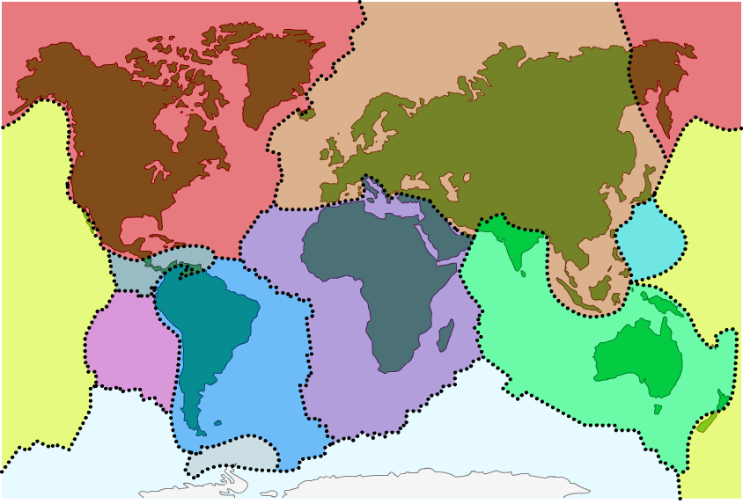

Plate Boundaries Worksheet Three
This worksheet accompanies Plate Boundaries.ppt

- Look at the pictures below and provide a description of what happens at the four different plate boundaries. Be sure to mention the following:
- The changes that take place under the Earth’s surface and the effects of convection currents.
- Oceanic and continental plates.
- The directions in which the plates move.
- How volcanoes, earthquakes and mountains are created.

Divergent
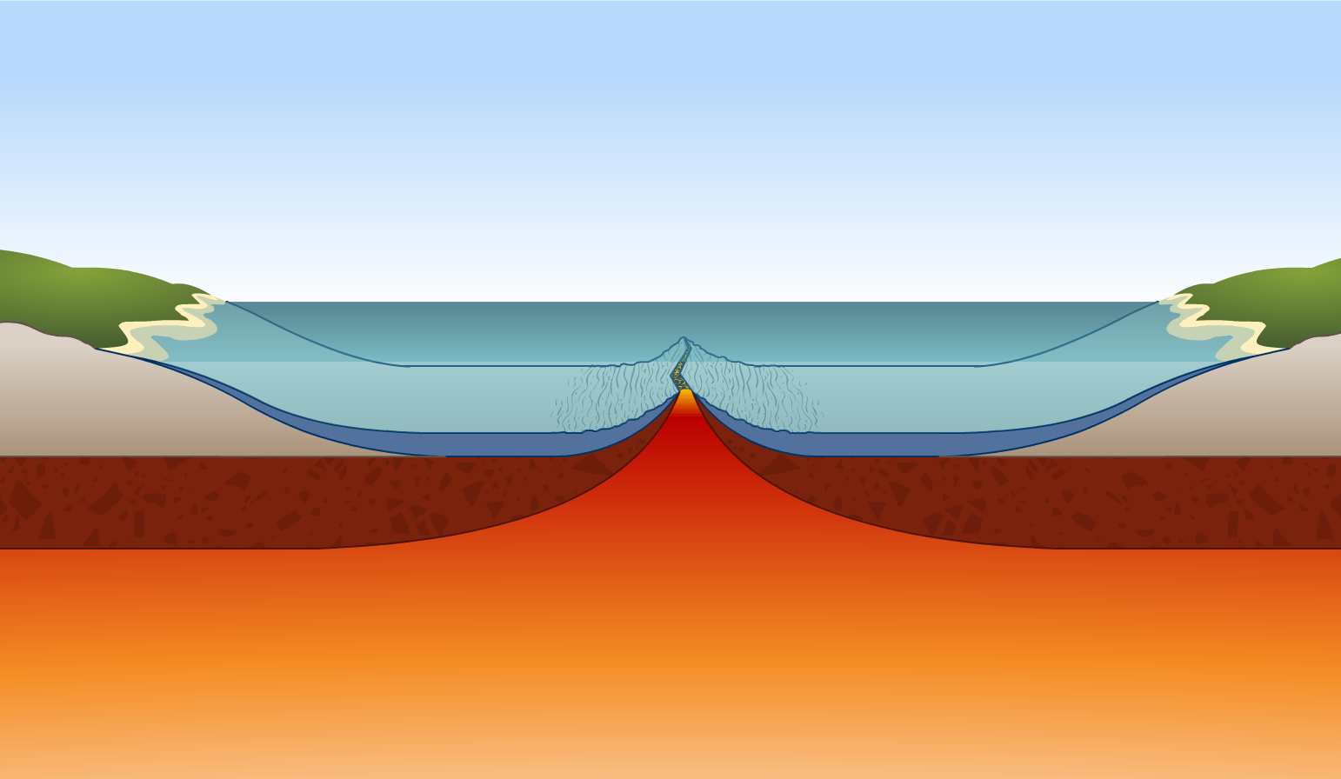
________________________________________________________________________________________________________________________________________________________________________________________________________________________________________________________________________________________________________________________________________________________________________________________________________________________________________________________________________________________________________________________________________________________________________________________________________________________________________________________________________________________________________________________________________________________________________________________________________________________________________________________________________________________________________________________________________________________________________________________________________________________________________________________________________________________________________________________________
_______________________________________________________________________________________________________________________________________________________________

Collision
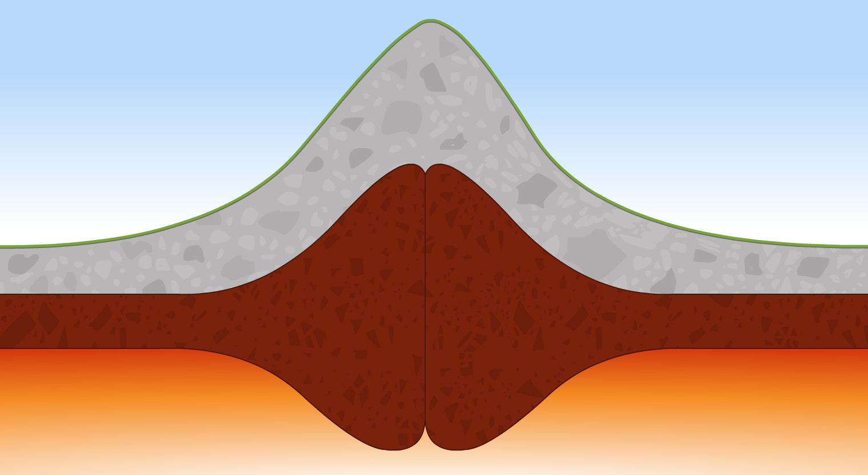
____________________________________________________________________________________________________________________________________________________________________________________________________________________________________________________________________________________________________________________________________________________________________________________________________________________________________________________________________________________________________________________________________________________________________________________________________________________________________________________________________________________________________________________________________________________________________________________________________________________________________________________________________________________________________________________________________________________________________________________________________________________________________________________________________________________________
________________________________________________________________________________________________________________________________________________________________________________________________________________________________________________________________________________________________________________________________________________________________________________________________________________________________________________________________________________________________
________________________________________________________________________________________________________________________________________________________________

Convergent
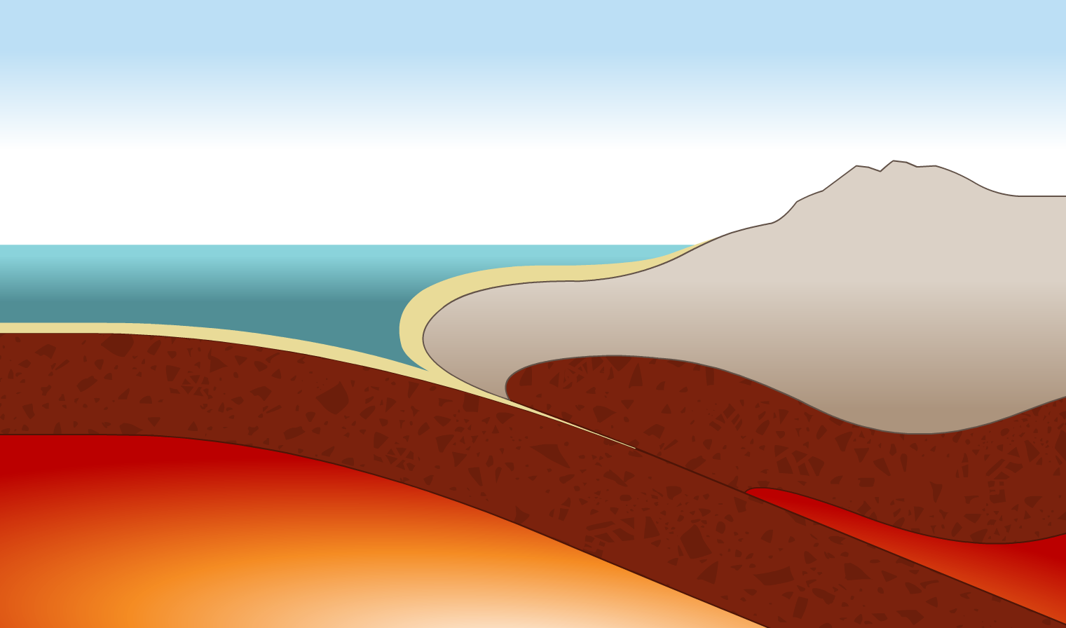
________________________________________________________________________________________________________________________________________________________________________________________________________________________________________________________________________________________________________________________________________________________________________________________________________________________________________________________________________________________________________________________________________________________________________________________________________________________________________________________________________________________________________________________________________________________________________________________________________________________________________________________________________________________________________________________________________________________________________________________________________________________________________________________
________________________________________________________________________________________________________________________________________________________________________________________________________________________________________________________________________________________________________________________________________________________________________________________________________________________________________________________________________________________________
________________________________________________________________________________________________________________________________________________________________

Transform




