Parallel Circuits Worksheet
This worksheet accompanies slide 10 of Parallel Circuits.ppt

Comparing series and parallel circuits
Conduct this experiment to investigate the differences between series and parallel circuits.

Decide whether each of these circuits is a series or parallel circuit and circle your answer:

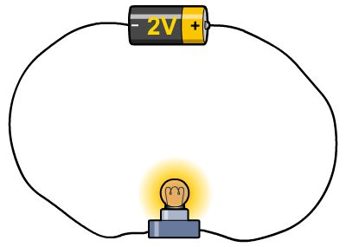
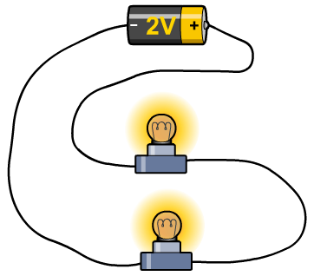
1. 2.

SERIES / PARALLEL SERIES / PARALLEL

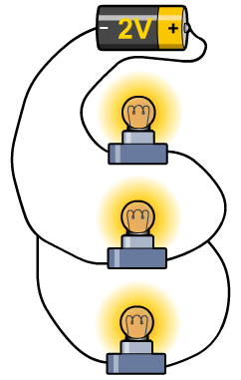
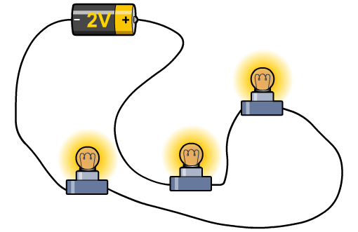
3. 4.

SERIES / PARALLEL SERIES / PARALLEL

Questions:

- Describe how voltage varies around a series circuit.
……………………………………………………………………………………………
……………………………………………………………………………………………

- How will the voltage of a series circuit be affected by the addition of more bulbs?
……………………………………………………………………………………………
……………………………………………………………………………………………

- How is the voltage around a parallel circuit affected by the addition of more bulbs?
……………………………………………………………………………………………
……………………………………………………………………………………………

- Consider the circuit below. If the supply voltage is 5 volts and all the bulbs are identical, what will be the reading at the voltmeter?
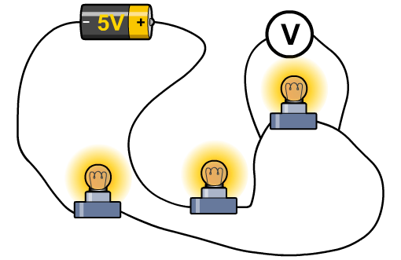

Voltmeter = ………………

