Moment Calculations Worksheet
This worksheet accompanies Moment Calculations.ppt

Investigating moments

Set up the apparatus as in the diagram below:
Attach a yardstick to a stand at the 50 cm mark using a ring clamp. Make sure that the nut connecting the ring clamp to the stand is not too tight, so that the yardstick can pivot.
Use two large paperclips as hooks for the weights, which can be moved to different places on either side of the yardstick.

You will need weights of 50 grams, 100 grams and 200 grams.

yardstick
ring clamp

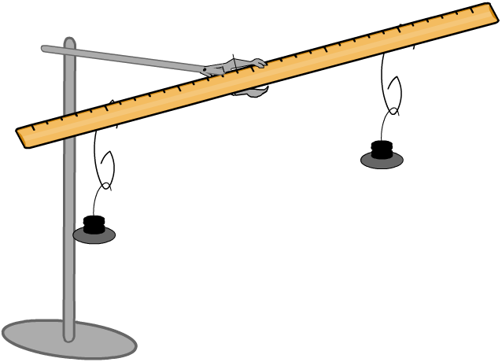
large paperclip
weights

- Where is the pivot?

……………………………………………………………………………………………

- Find five different combinations of weights and distances that ensure that the yardstick is still balanced. The distances from the pivot can be measured from the ruler.
For example, you might find that 200 g attached on the left hand side, 10 cm from the pivot, exerts a counterclockwise moment equal to 100 g attached on the right hand side, 20 cm from the pivot.
Fill in all your results in the table. The above example has been filled in for you.

Clockwise |  |  | Counterclockwise
Mass | Distance from pivot | Moment | Mass | Distance from pivot | Moment
200 g | 10 cm | 2000 gcm | 100 g | 20 cm | 2000 gcm

- What do you notice about the relationship between clockwise moments and counterclockwise moments when the ruler is balanced?

……………………………………………………………………………………………
……………………………………………………………………………………………
- Moments are more usually measured in newton meters (Nm).
Convert your first 3 results into newtons, meters and newton meters.

Clockwise |  |  | Counterclockwise
Weight | Distance from pivot | Moment | Weight | Distance from pivot | Moment
2 N | 0.1 m | 0.2 Nm | 1 N | 0.2 m | 0.2 Nm

