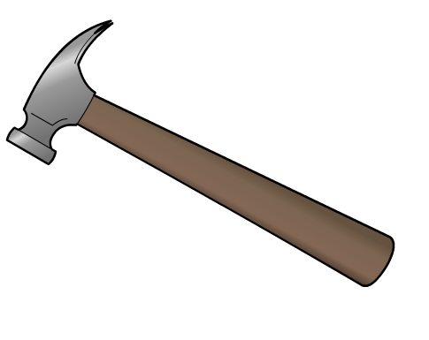
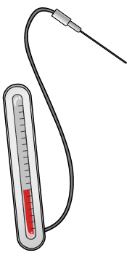
Metals and Nonmetals Worksheet
This worksheet accompanies slide 4 of Metals and Nonmetals.ppt

What are the properties of metals and nonmetals?
Watch the virtual experiment and fill in the table below.

Test | Property being tested | How is the property tested? | What happens to the metal? | What happens to the nonmetal?
1 | How strong is it?
2 | How malleable is it?
3 | Does it conduct electricity?
4 | Does it conduct heat?
5 | Is it shiny or dull?
6 | Is it sonorous?

Write down what you think each of these words mean:

Strong:
………………………………………………………………………………………………………………

Malleable:
………………………………………………………………………………………………………………

Conductor:
………………………………………………………………………………………………………………

Shiny:
………………………………………………………………………………………………………………

Sonorous:
………………………………………………………………………………………………………………

Write a list of the typical properties of metals and nonmetals:
Metals Nonmetals
………………………………………..….……….. .………….…………………………………………
………………………………………..….……….. .………….…………………………………………
………………………………………..….……….. .………….…………………………………………
………………………………………..….……….. .………….…………………………………………
………………………………………..….……….. .………….…………………………………………
………………………………………..….……….. .………….…………………………………………

 
 

