Magnetic Materials Worksheet
This worksheet accompanies slide 5 of Magnetic Materials.ppt

What materials block magnetic attraction?
Conduct this experiment to find out which materials block the effect of magnets.

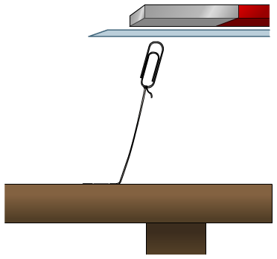
Equipment

- Workbench
- Paperclip
- Thread
- Bar magnet
- Materials to test
- Ruler

- Tie the end of the thread to the paperclip. Measure out the thread and then tape it to the workbench so that there is 10 cm of thread between the bench and the paperclip.
- Hold the bar magnet above the paperclip to confirm that there is a magnetic attraction. You should be able to hold the magnet so that there is a gap between the magnet and the clip, but the clip is still attracted and at the length of the thread.
- Now insert thin sheets of different materials between the magnet and the paperclip (as shown above). Record what you observe.

What do you need to ensure about the sheets of material in order to make this test fair?

………………………………………………………………………………………………

If the following materials are used, can you predict which will block the effect of the magnet?
Circle your answers.

Paper Steel Aluminum

Iron Polythene Copper

Record the results of your experiment in the table below.
There is space to add extra materials of your own.

material tested | Was the paperclip still attracted? | observations
Paper
Steel

Aluminum
Iron
Polythene
Copper

- Which materials allow magnetic attraction to act through them?

………………………………………………………………………………………………
………………………………………………………………………………………………………………………………………………………………………………………………

- Which materials block the effects of the magnet?

………………………………………………………………………………………………………………………………………………………………………………………………………………………………………………………………………………………………

- Was your prediction about which materials would block magnetic attraction correct?

………………………………………………………………………………………………

- Use the results of your experiment to write a new statement predicting the types of material that will allow magnetic attraction to act through them.

………………………………………………………………………………………………………………………………………………………………………………………………………………………………………………………………………………………………

- Use your conclusion to predict which of the following materials will block magnetic attraction. Circle your answers.

Cobalt Nickel

Gold Silver

