Looking at Cells Worksheet One
This worksheet accompanies slides 2 & 3 of Looking at Cells.ppt

What is the difference between onion and cheek cells?
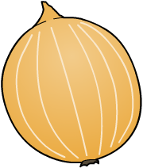
Complete the activities below…

1. Using a pencil, draw sketches of the onion and check cells.
Note below what magnification you used to view the cells.
Cheek cells
Onion cells

Magnification: x ………………… Magnification: x …………………

2. Label your sketches to indicate any organelles or structures that you saw.

3. Using your knowledge about cells, list the differences between onion and cheek cells

……………………………..………….………………………………..……………………………………

…………………………………………………………………………….…………………………………

……………………………………………….…………………………….…………………………………

Looking at Cells Worksheet Two
This worksheet accompanies slide 4 of Looking at Cells.ppt

What are the parts of a microscope?
Fill in the diagram below…

Label the different parts of the microscope using the following words:
- objective lens
- eye piece lens
- coarse focusing wheel
- fine focusing wheel

- stage
- light source

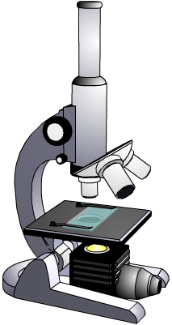

Use the space below to write down the safety information about using a microscope your teacher
tells you:

……………………………..………………………………………..……………………………………

……………………………..………………………………………..……………………………………

