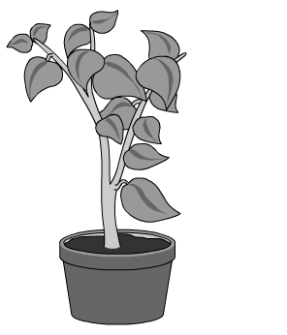
Leaves and Glucose Worksheet
This worksheet accompanies slide 7 of Leaves and Glucose.ppt

Part 1
Do plants really need light?
Use this worksheet to write up the results of the dark and light experiment.

Purpose
What are you trying to find out?

……………………………………………………………………………………………..…………………

……………………………………………………………………………………………..…………………

Hypothesis
Describe what you think the results will show.

……………………………………………………………………………………………..…………………

……………………………………………………………………………………………..…………………

……………………………………………………………………………………………..…………………

Method
Write a step-by-step guide describing how the experiment was carried out and what materials were used.

……………………………………………………………………………………………..…………………

……………………………………………………………………………………………..…………………

……………………………………………………………………………………………..…………………

……………………………………………………………………………………………..…………………

……………………………………………………………………………………………..…………………

……………………………………………………………………………………………..…………………

……………………………………………………………………………………………..…………………

How did you make sure all the other factors (e.g. temperature, water) were kept the same?

……………………………………………………………………………………………..…………………

……………………………………………………………………………………………..…………………

……………………………………………………………………………………………..…………………
Results
Draw a table below to show the results of this experiment.

Discussion
Are the results what you expected?

……………………………………………………………………………………………..…………………

……………………………………………………………………………………………..…………………

How do you think the experiment could be improved?

……………………………………………………………………………………………..…………………

……………………………………………………………………………………………..…………………

Conclusion
What do the results show?

……………………………………………………………………………………………..…………………

……………………………………………………………………………………………..…………………

……………………………………………………………………………………………..…………………
Part 2
Do plants really need carbon dioxide?
Use your knowledge about photosynthesis to predict the results of the following experiment.

An experiment is carried out to investigate the effect of light and carbon dioxide on plants. Four healthy plants of the same type are selected. The plants are placed in bell jars and grown for a week. The conditions in which they are grown are shown below.

plant 1 plant 2 plant 3 plant 4
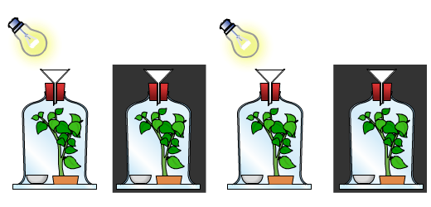
with sodium hydroxide with sodium bicarbonate

sodium hydroxide (soda lime) absorbs carbon dioxide
sodium bicarbonate releases carbon dioxide

After a week a leaf from each plant is tested with iodine.

Using the information on the previous page, describe the conditions in which each plant is grown, e.g. in light, with carbon dioxide. Write your answers in the first column. In the second column state the outcome you would expect from testing a leaf from each plant with iodine i.e. red/brown or blue/black.

 | growing conditions | color of iodine
plant 1

plant 2

plant 3

plant 4

