

Human Behavior Worksheet
This worksheet accompanies slide 6 of Human Behavior.ppt

Fight or flight reactions
Using the animation, answer the following questions.

1. What was the stimulus for this behavior?

………………………………………………………………………………………………

2. Identify 4 organs in the body that are involved in coordinating the response.
Mark them on the diagram using labels.
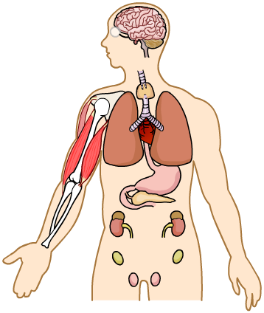

3. What behavioral response did the man show to the stimulus?

………………………………………………………………………………………………

4. How do you think this response is useful for humans?

………………………………………………………………………………………………

………………………………………………………………………………………………

………………………………………………………………………………………………

