How Microbes Cause Disease Worksheet
This worksheet accompanies slide 4 of How Microbes Cause Disease.ppt

The spread of cholera
Look at the information provided and answer the questions below.

Cholera is a disease that causes severe diarrhea and vomiting. In the 19th century many people in the U.S. died of cholera because people did not understand what causes the disease or
how it spreads.

In 1854 there was a large outbreak of cholera in London, England. A local doctor named John Snow noticed that most of the affected people lived in the same area. By studying the outbreak more closely, Snow found that the affected people had got their drinking water from the same pump on Broad Street. The map below shows the houses affected by cholera and the locations of the nearby pumps.

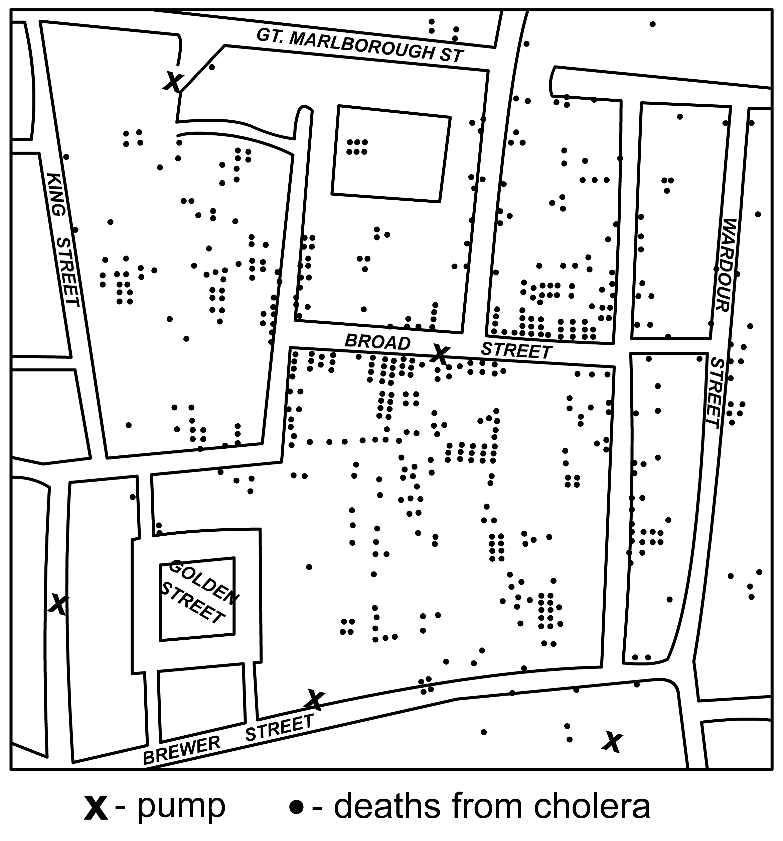

John Snow developed a theory that cholera was being spread in water from the Broad Street pump. He believed that if people did not use the pump cholera would not spread any further.
He was right, and probably saved many lives.

1. What evidence was there to lead John Snow to his theory?

………………………………………………………………………………………………….…………

………………………………………………………………………………………………….…………

2. What is a theory?

………………………………………………………………………………………………….…………

………………………………………………………………………………………………….…………

Cholera is spread by drinking water that has come into contact with human feces. Recent cases of cholera include several outbreaks following the Asian tsunami in December 2004.

3. What do you think caused cholera outbreaks after the Asian tsunami?

………………………………………………………………………………………………….…………

………………………………………………………………………………………………….…………

4. What precautions would you recommend to someone going to an area with cholera?

………………………………………………………………………………………………….…………

