Growing Plants Worksheet
This worksheet accompanies slide 4 of Growing Plants.ppt

Growing plants
Complete the activities below.
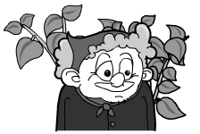
Martha is having trouble with her garden. Some of her plants
have mineral deficiencies and weeds are taking over.

Fill in the table below by deciding which type of mineral Martha should add to the soil to make each plant healthy again. Check the boxes to show your answers.

 | description of plant | magnesium | nitrogen | phosphorus | potassium
plant 1 | yellow leaves with dead spots
plant 2 | discolored purple leaves  and poor root growth
plant 3 | poor flower and fruit growth
plant 4 | poor growth, weak stems  and dead lower leaves

Give two ways Martha could get rid of the weeds in her garden.

1.………………………………………………………………...……………………………

2.………………………………………………………...……………………………………

If Martha decided to grow plants organically, how could she make sure that her soil is kept rich in nutrients?

….……………………………………………………………………………………………

