Graphing Speed Worksheet
This worksheet accompanies slide 6 of Graphing Speed.ppt

Looking at speed-time graphs
Look at the graph and answer the questions below…

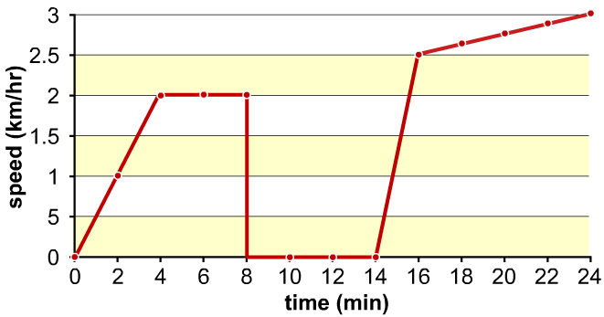
Peter walks to school every day. However, he likes to dawdle and is nearly always late. The speed-time graph below shows one of his journeys to school. During his journey he meets a friend on the street – they stop and talk for while.

- When did Peter stop to talk to his friend? Label this point on the graph.
- Did Peter walk faster before or after he met his friend?
…….……………………………………………………………………………………………………
- What was Peter’s highest speed?
…….……………………………………………………………………………………………………
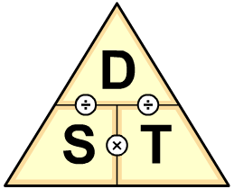
- Using the graph and the formula triangle calculate how far Peter walked in the first 4 minutes.
…….……………………………………………………………………………………
…….……………………………………………………………………………………
- What advice would you give to Peter to make his trip to school take less time?
…….……………………………………………………………………………………………………
…….……………………………………………………………………………………………………

