Friction Worksheet
This worksheet accompanies slide 10 of Friction.ppt

Streamlining practice – customizing cars

Cars are usually designed to be streamlined – this means that they have shapes that create as little air resistance as possible when they move forwards.

In this assignment, your task is to make the LEAST streamlined car you can.

Here is an example of an unstreamlined car:
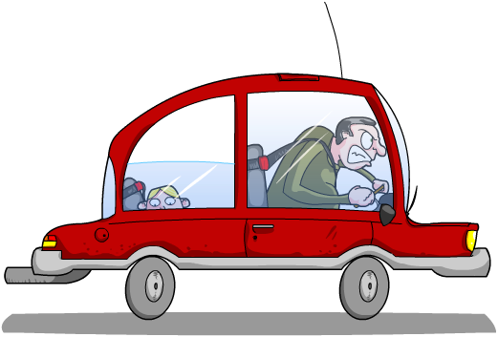
What do you notice about the shape of this car?

…………………………………………
…………………………………………
…………………………………………
…………………………………………

Equipment list for this task:

- Paper
- Glue
- Scissors
- Toy car (or dynamics trolley)
- Ramp or runway
Your teacher will need:
Datalogger or speed sensor/motion sensor

Use the paper to change the shape of your car so that it creates the most air resistance. You may test the car by letting it roll down your ramp. Remember, the slower the better!

The winner will be decided by your teacher. Each car will be rolled down the ramp three times and the average time taken by each car calculated and compared.

How did you do? Record your rank in the class below.

