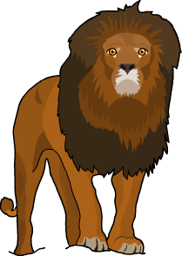
Food Chains Worksheet
This worksheet accompanies slide 2 of Food Chains.ppt

What are the feeding relationships in the Masai Mara?
Read the information provided and answer the questions below.

The Masai Mara is an area of grassland in East Africa, where herds of wildebeest and zebra graze.
They are hunted by big cats such as lions.

The Mara River runs through the area. The animals have to cross it to reach new pastures. In the river are crocodiles that have adapted to catch wildebeest and zebra as they cross. Hippos also live in the river; however, they only feed on grass and aquatic plants.

The Masai are a local tribe of huntsmen who keep cattle on the grassland and who also hunt wildebeest and zebra for meat. Their cattle are occasionally attacked and eaten by lions.

1. Draw lines to match each description with the correct animal.
producer

hippo

predator

Mara River

zebra
prey

consumer

grass

habitat

lion

2. Write three different food chains using the organisms of the Masai Mara:

……………..…..………… → …………..…..…………… → …………..………..………

……………..…..………… → …………..…..…………… → …………..………..………

……………..…..………… → …………..…..…………… → …………..………..………

3. Which animals in this habitat are secondary consumers?

……………………………..………………………………………..………………………………………

