Environmental Change Worksheet
This worksheet accompanies slide 6 of Environmental Change.ppt

How is deforestation affecting animals?
Read the information provided and answer the questions below…
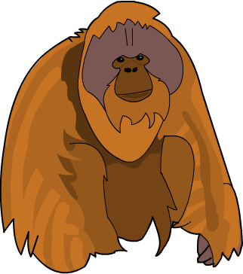
The orangutan is a shy solitary ape that lives in the trees of the rainforest in Asia. It eats fruit, leaves and shoots.

It is thought that orangutans in parts of Asia such as Borneo are at risk of extinction. There has been massive deforestation in this area and a recent influx of humans.

1. Why is it important to prevent species from becoming extinct?

……………………………..………………………………………..………………………………………

……………………………..………………………………………..………………………………………

2. How do these features help the orangutan survive in its environment?

Long, strong arms …………………………..………………………………………..…….………………

……………………………..………………………………………..………………………………………

Curved feet …………………………..………………………………………………..……………………

……………………………..………………………………………..………………………………………

3. How could deforestation be causing a decline in the number of orangutans?

……………………………..………………………………………..……………………………………

……………………………..………………………………………..……………………………………

4. Other than deforestation, what other human activity is likely to cause a decline in ape populations?

……………………………..………………………………………..……………………………………

