Elements and Compounds Worksheet
This worksheet accompanies slide 13 of Elements and Compounds.ppt

A compound is not a mixture

Look at the pictures below and then answer the questions on the next page.

A B
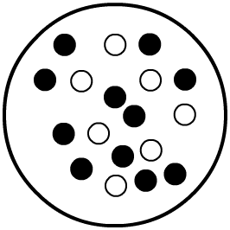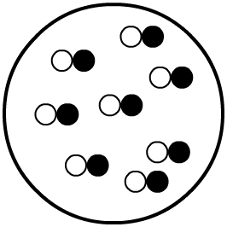

C D
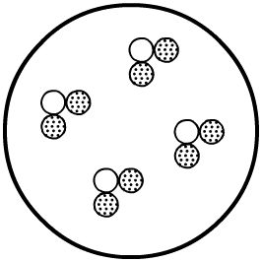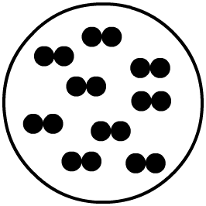

E F
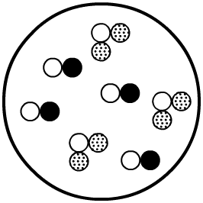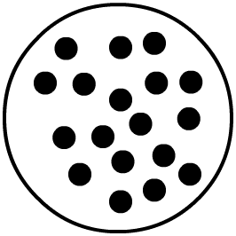

- Which picture represents:
a) atoms of an element answer = ………….

b) molecules of an element answer = ………….

c) molecules of a compound made of two elements answer = ………….

d) molecules of a compound containing three atoms answer = ………….

e) a mixture of elements answer = ………….

e) a mixture of compounds answer = ………….

2. Complete these sentences using answers from the box below:
a) diagram A could represent ………….………….………….………….………….………….………

b) diagram B could represent ………….………….………….………….………….………….………

c) diagram C could represent ………….………….………….………….………….………….………

d) diagram D could represent ………….………….………….………….………….………….………

e) diagram E could represent ………….………….………….………….………….………….………

f) diagram F could represent ………….………….………….………….………….………….………

