Earthquakes Worksheet One
This worksheet accompanies slide 2 of Earthquakes.ppt

1. Name the tectonic plates on the map.

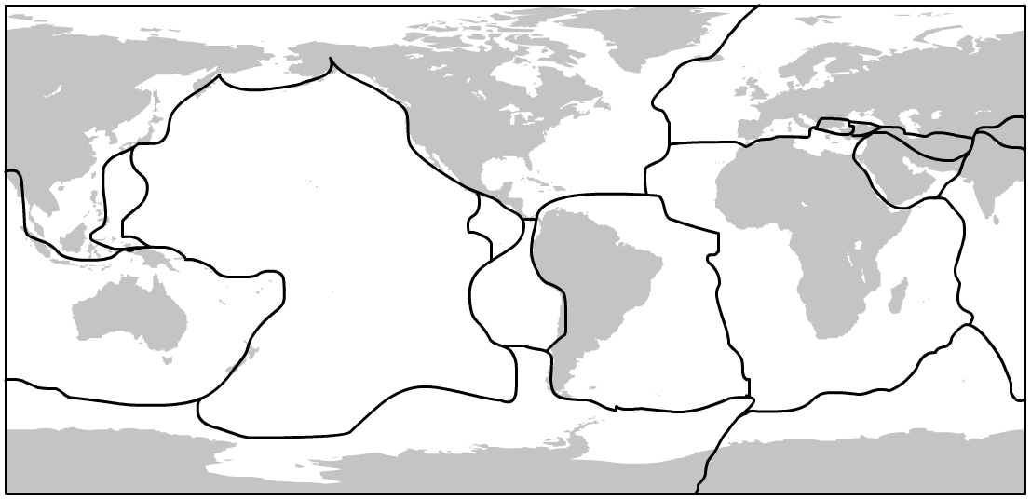

2. Mark the epicenter locations of recent earthquakes. For example, the 2005 Pakistan earthquake, the 2006 Indian Ocean earthquake and the 2008 Sichuan earthquake in China.

3. Label the earthquake locations with the magnitude of the earthquake and the number of people who died as a result.

Earthquakes Worksheet Two
This worksheet accompanies slide 9 of Earthquakes.ppt

Use the descriptions of the points on the Mercalli scale to draw pictures or cartoons, or find photos on the internet to show the destruction observed at each point on the scale.

Scale 1: Felt by almost no one but seismographs register a reading. | Scale 2: Felt by very few people. | Scale 3: Tremor noticed by many, but they often do not realize it is an earthquake.
Scale 4: Felt indoors by many. Feels like a truck has struck the building. | Scale 5: Felt by everyone; many people are awakened. Swaying trees and poles may be observed. | Scale 6: Felt by all; many people run outdoors. Furniture is moved.
Scale 7: Everyone runs outdoors. Poorly built structures considerably damaged. Slight damage elsewhere. | Scale 8: Specially designed structures damaged slightly, others collapse. | Scale 9: All buildings considerably damaged, many shift off foundations. Noticeable cracks in the ground.
Scale 10: Many structures destroyed. Ground badly cracked. | Scale 11: Almost all structures fall. Bridges wrecked. | Scale 12: Total destruction. Waves seen on ground surfaces.

