Different Types of Rocks Worksheet
This worksheet accompanies slide 3 of Different Types of Rocks.ppt

Identifying rocks

Watch the virtual experiment and record your observations in the tables below. The results for sandstone have been filled in for you as an example of what to write.

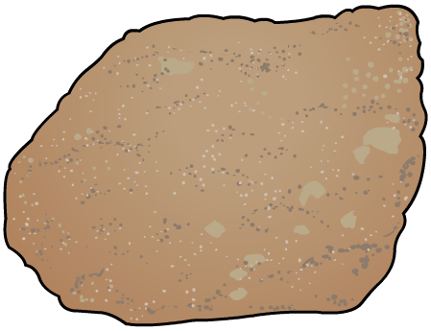 | Sandstone
Appearance | Layers of compressed mineral grains. Orangey-brown in color.
Hard or soft? | Soft. Crumbles easily.
Porosity | Very porous, absorbs large quantities of water.

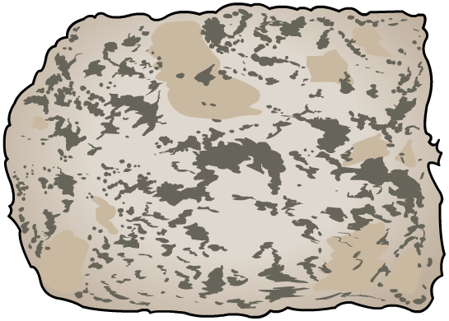 | Granite
Appearance
Hard or soft?
Porosity

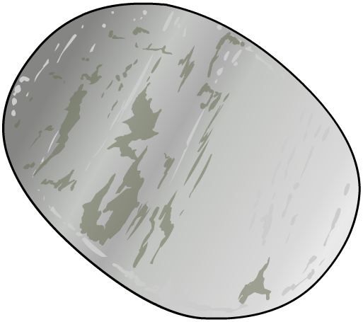 | Marble
Appearance
Hard or soft?
Porosity

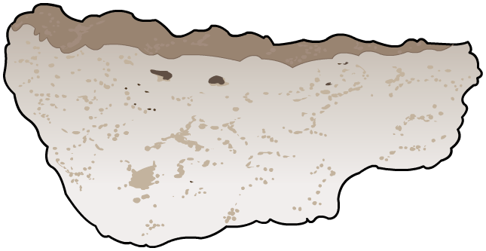 | Limestone
Appearance
Hard or soft?
Porosity

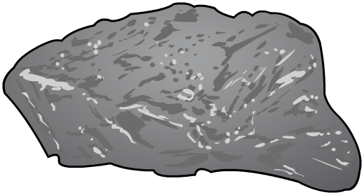 | Basalt
Appearance
Hard or soft?
Porosity

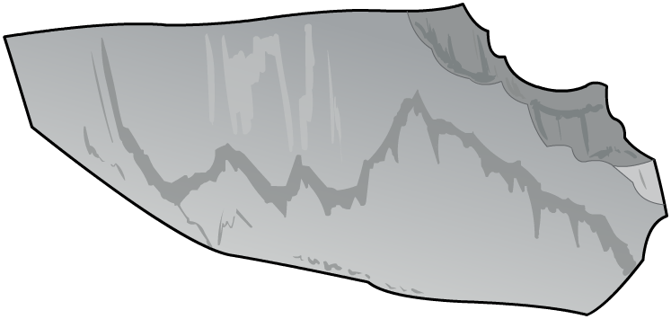 | Slate
Appearance
Hard or soft?
Porosity

