Conduction and Convection Worksheet
This worksheet accompanies slide 2 of Conduction and Convection.ppt

Investigating conduction
This experiment is designed to test the speed with which different materials conduct heat.

Set up a Bunsen burner and tripod as shown below. Attach a blob of wax to the end of a uniform rod made from the material you want to test and securely place it on the tripod so that it will not tip. Gently heat the end of the rod furthest from the wax with the Bunsen.

Use a stopwatch to time how long it takes for the wax to melt and fall from the rod.

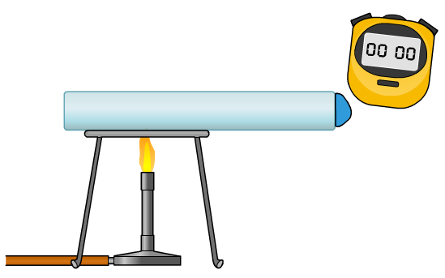

rod

wax
Bunsen burner
tripod

Test at least four different substances. Make sure that you choose a good range.
Here is a suggested list:

- Copper
- Iron
- Steel
- Glass
- Ceramic

Record your results in the table below:

Material | Time taken (s)

- Plot a bar chart of your results below.
Material 2
Material 1
Material 3
Material 4
Material 5
Time (s)
0

- How did you make your experiment a fair test?

……………………………………………………………………………………………
…………………………………………………………………………………………………………………………………………………………………………………………

- How did you ensure the experiment was safe?

……………………………………………………………………………………………
…………………………………………………………………………………………………………………………………………………………………………………………

- Which material was the best conductor of heat?

……………………………………………………………………………………………

- Which material was the worst conductor?

……………………………………………………………………………………………

- Did you notice any patterns in your results? Can you say what types of material tend to conduct heat the fastest?

……………………………………………………………………………………………
………………………………………………………………………………………………………………………………………………………………………………………………………………………………………………………………………………………

