Classifying Organisms Worksheet
This worksheet accompanies slide 6 of Classifying Organisms.ppt

What’s in your backyard?
Use this dichotomous key to classify some common backyard animals.

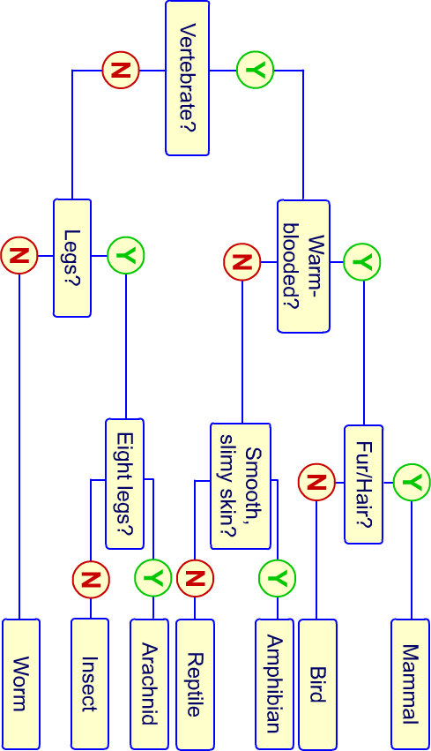

Now fill in the blanks to make your own dichotomous key.
You could classify candy, shoes, pens, cars or anything else you can think of. Then trade worksheets with a friend and see if they can figure out how to use your key.

