Chemical Weathering Worksheet
This worksheet accompanies slide 4 of Chemical Weathering.ppt

Which type of weathering?

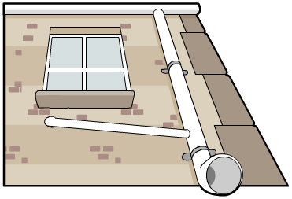
Look around your environment and see if you can find ten examples of weathered
rock. You could look at statues or gravestones, your house, your school or any
other buildings you find. Record your observations about the weathered rock in
the table below, highlighting where you found the weathering, what you think
caused it and what effect it has had. Remember that weathering can be caused by
wind, rain, hot and cold weather, plants and animals.

Location |  | What caused the weathering? | What effect has it had?
e.g. | A wall in the school playground. | Water dripping from leaky guttering. | A channel has been worn in the bricks where the water has run down.
1
2
3
4
5
6
7
8
9
10

