Chemical Digestion Worksheet
This worksheet accompanies slide 8 of Chemical Digestion.ppt

Which enzyme?
Complete the table below and answer the questions below.

1. Fill in the table below to show which substrates and products are involved with each enzyme.
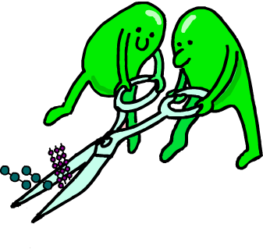
substrate = a substance that is broken down by an enzyme
product = a substance that is produced by break down by enzymes

enzyme | substrate | product
carbohydrase
 | protein
lipase |  | fatty acid and glycerol

2. Which organ in the digestive system produces and secretes enzymes? Put a check in the correct box.
stomach
pancreas
small intestine
large intestine

3. Enzymes are often used in laundry detergents. How do you think enzymes might help to clean clothes?

……………………………..………………………………………..……..…………………………………

……………………………..…………………………………………....……………………………………

……………………………..………………………………………..………..………………………………

……………………………..………………………………………..………….……………………………

