Changes of Matter Worksheet
This worksheet accompanies slide 6 of Changes of Matter.ppt

Melting point and boiling point
Read the following instructions, and then fill in the table on the next page.

How to figure out what state a substance is at any given temperature:
- Draw a scale.
- Write ‘solid’ below the melting point, ‘liquid’ between the melting and boiling points, and ‘gas’ above the boiling point.
- Write down the melting point (°C) and boiling point (°C) of the substance you are looking at.
- Find the temperature you are looking for on the scale – it should now be clear whether the substance is a solid, a liquid or a gas.

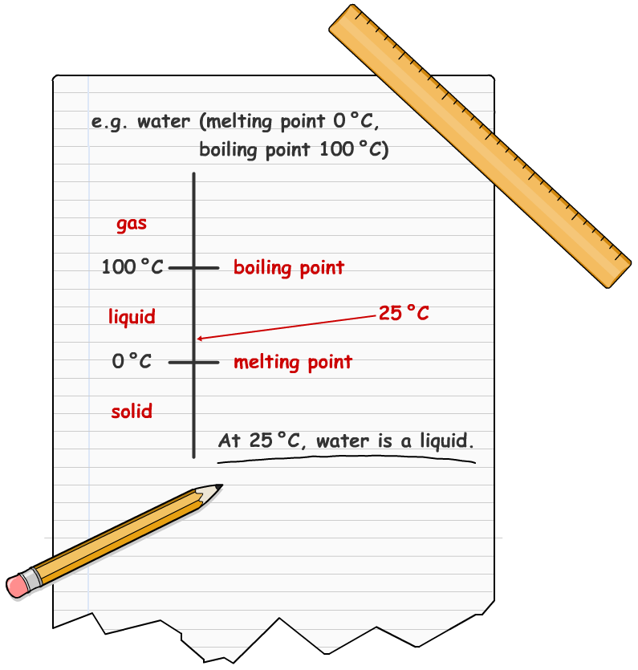

Substance | Melting point (°C) | Boiling point (°C) | State at 25 °C | State at 1000 °C | State at -50 °C
water | 0 | 100
methane | -182 | -162
oxygen | -218 | -183
ethanol | -117 | 79
ethanoic acid | 16.6 | 118
sodium chloride | 801 | 1467
xenon | -112 | -108
iron | 1535 | 2861
gold | 1063 | 2856
antimony | 630 | 1587
mercury | -39 | 357
yttrium | 1526 | 3336
ammonia | -77 | -33
hydrochloric acid | -27 | 48
osmium | 3033 | 5012

