Average and Instantaneous Speed Worksheet
This worksheet accompanies slide 4 of Average and Instantaneous Speed.ppt

Which car is the fastest?
Calculate the average speed of each car in the animation and answer the questions below.


To calculate the average speed you will need to convert the time taken from seconds into hours.

 | Time taken (s) | Time taken (hr) | Speed (km/hr)
Sector 1
Sector 2
Sector 3
 |  | average speed:

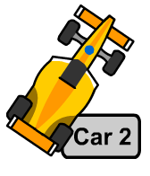

 | Time taken (s) | Time taken (hr) | Speed km/hr)
Sector 1
Sector 2
Sector 3
average speed

 | Time taken (s) | Time taken (hr) | Speed (km/hr)
Sector 1
Sector 2
Sector 3
 |  | average speed:

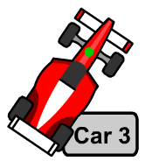

 | Time taken (s) | Time taken (hr) | Speed (km/hr)
Sector 1
Sector 2
Sector 3
 |  | average speed:

1. Which car had the highest average speed? …….……………………………………………………….
2. Which was the fastest sector of the track? …….………………………………………………..………
3. What was the top speed that was reached by the cars? …………………………………………………
4. Did the car that reached the top speed win the race? …………………………………………………

