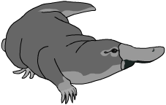
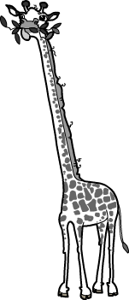
Adaptations Worksheet
This worksheet accompanies slide 3 of Adaptations.ppt

Can you design a well adapted animal?
Design an animal that is suited to a specific environment.

Choose one of the three habitats described below:
Marine
This watery environment
is home to a huge range
of animals, including predators.
Antarctic
This hostile environment is very cold and empty. Most of the food can be found in the water.
Rainforest
There’s plenty to eat in this hot, humid place. However, you’ve got to be able to
catch it first.

Choose which features below are suitable for an animal in the environment you have chosen.
- gills
- scales
- good eyesight
- sharp teeth

- thick fur
- feathers
- sharp claws
- wings

- beak
- webbed feet
- waterproof fur
- strong arms

Using the features you’ve chosen, draw your animal in the box below. Don’t forget to add color.
Add labels to explain why each adaptation is useful.

