Worksheet One
This worksheet accompanies slide 4 of Using Technology.ppt

Typing skills
Using the correct hand positions when typing can make typing easier and more comfortable. Can you remember which finger you should use to type each letter? Write each letter in the outline of the finger you should use to type that letter. You can refer to a keyboard for help.

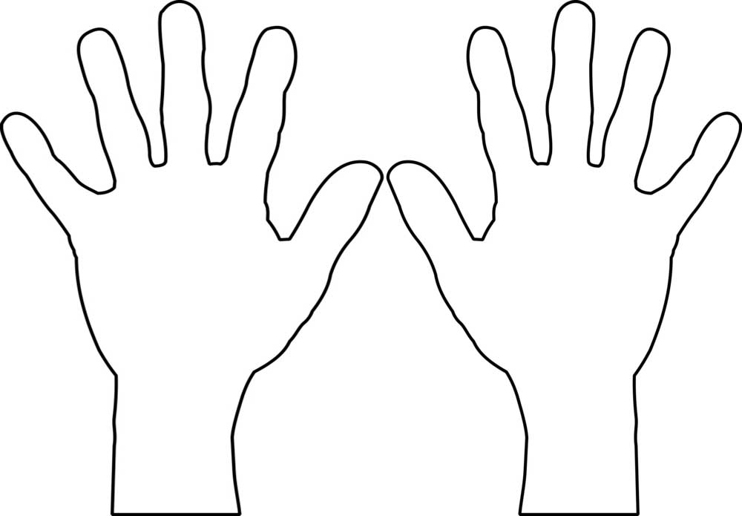

Worksheet Two
This worksheet accompanies slide 10 of Using Technology.ppt

Editing
Read these sentences. Use a thesaurus, either in print or on your computer, to try and replace the underlined words. Make sure that you know the meaning of the synonym you choose and it makes sense in the sentence. You can also rewrite the whole sentence to make it more interesting.

- At the end of the story, Sarah goes to the finish line and she wins the race.
_________________________________________________________________
_________________________________________________________________
- The story was good because it had many interesting characters.
_________________________________________________________________
_________________________________________________________________
- There are many parts of the book I liked. The best part was when the main character escaped from jail.
_________________________________________________________________
_________________________________________________________________
- The beginning of the story was good because the description of the scenery was nice and clear. The writing was good because it used a lot of descriptive words when describing the people and places.
_________________________________________________________________
_________________________________________________________________
_________________________________________________________________
- The end of the novel was very funny because the characters were confusing each other and didn’t understand what was going on.
_________________________________________________________________
_________________________________________________________________

Worksheet Three
This worksheet accompanies slide 11 of Using Technology.ppt

Constructive comments
Read each of these comments and try to rephrase them so that they are more constructive. You may need to change the wording, add in helpful suggestions or pair them with a positive comment.

Negative  comment | Constructive  comment
1. You’re wrong.

2. This sentence doesn’t make any sense.

3. This quote doesn’t work here.

4. Your essay has a weird ending.

5. This isn’t a thorough summary.

