Works and Power Worksheet
This worksheet accompanies Work and Power.ppt and Powering Cars.ppt

1. Fill in the gaps.

a. Work done = ………………… × distance.
b. When work is done, a force moves an object and ………………… is transferred.
c. Energy transferred is ………………… to work done.
d. Force is measured in …………………
e. Work done by a force is measured in …………………

force energy equal different newtons (N) joules (J) power kilograms (kg)

2. If a rocket transfers 2,500,000 MJ of energy when it takes off, how much work is done?

……………………………………………………………………………………….......
……………………………………………………………………………………….......
……………………………………………………………………………………….......

3. A bodybuilder lifts a 10 N weight a distance of 2.5 m.
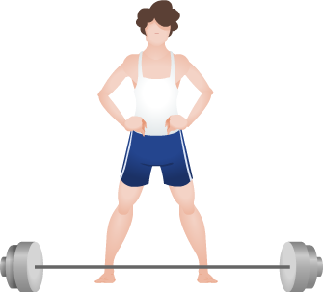
How much energy has the weight gained?

…………………………………………………………
…………………………………………………………
…………………………………………………………
…………………………………………………………
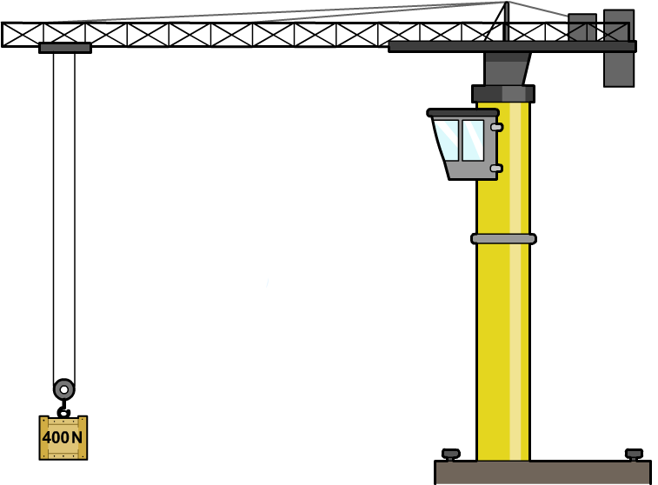
4. A crane lifts a 400 N crate full of baked beans 15 m.
How much work was done by the crane?

…………………………………………………………
…………………………………………………………
…………………………………………………………
…………………………………………………………
…………………………………………………………

5. Power is the work done or energy transferred in a given time. What is the equation used to calculate power? Include the units of measurement.

………………………………………………………………………………………………….………..

6. Give one everyday example in which work is done and power is developed,
e.g. climbing stairs, pushing a shopping trolley.

.....................................................................................................................................................

7. Two speedboats of an equal mass are about to have a 100 m race. One boat has a slightly more powerful engine than the other. Which boat is more likely to win the race and why? Explain your answer in terms of the rate at which work is done and chemical and kinetic energy transfer.

…………………………………………………………………………………………………………………………………………………………………………………………………………………………………………………………………………………………………………………………………………………………………………………………………………………………………………………………………………………………………………………………………………………………………
8. A moped transfers 7 MJ of energy in 5 minutes. Calculate the power of the moped.

………………………………………………………………………………………………………………………………………………………………………………………………………………………………………………………………………………………………………………………………………………………………………………………………………………………………………………………………………………………………………………………………………………………………………………………………………………………………………………………………………………

9. A jeep pulls a caravan with a force of 2,000 N over a distance of 20,000 m in 2 hours. How much power does the jeep produce? Remember to calculate the work done first.

……………………………………………………………………………………………………………………………………………………………………………………………………………………………………………………………………………………………………………………………………………………………………………………………………………………………………………………………………………………………………………………………………………………………………………………………………………………………………………………………………………………………………………………………………………………………………………………………
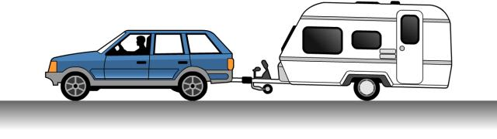
10. Use the data in the table to answer the following questions about fuel consumption.
type of car | engine size | fuel type | fuel consumption  (miles per gallon) | C0₂ emissions
Vauxhall Corsa | 1,419 cc | petrol | 66.2 | 107 g/km
VW Golf | 1,999 cc | diesel | 71.6 | 73 g/km
Audi A3 | 2,319 cc | petrol | 35.9 | 140 g/km
Suzuki Swift | 1,399 cc | diesel | 79.1 | 66 g/km

a. What can you observe about the relationship between the size of a car’s engine and its fuel consumption?

………………………………………………………………………………………………………………………………………………………………………………………………………………

b. The Vauxhall Corsa and the Suzuki Swift have similar-sized engines.
Which is the more environmentally friendly?

………………………………………………………………………………………………………

c. Which car would be the most expensive to run?

………………………………………………………………………………………

11. Give two possible alternatives to using fossil fuels to power cars.

…………………………………………………………………………………………………………………………………………………………………………………………………………………………

