Waves Worksheet
This worksheet accompanies Waves in Space.ppt,
Diffraction Dispersion and Interference.ppt, and Total Internal Reflection.ppt

1. Complete the ray diagrams below to show what happens when light is incident on a semi-circular glass prism.
c is the critical angle.

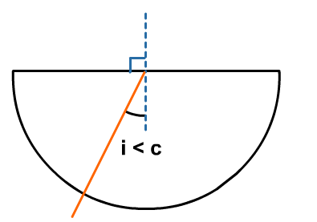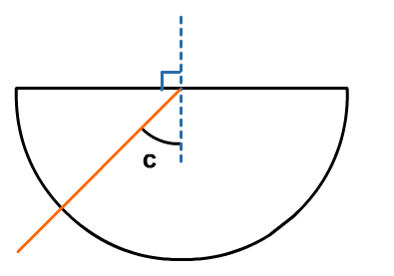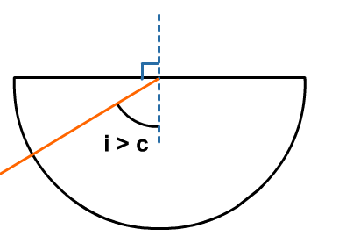

2. Calculate the critical angle for light passing across the following boundaries:
n is the refractive index.

a. Perspex (n = 1.5) to air (n = 1)

b. glass (n = 1.5) to water (n = 1.33)

c. What happens if you try to calculate the critical angle for light passing from water to glass? Why does this happen?

…………………………………………………………………………..…………………………………
…………………………………………………………………………..…………………………………
…………………………………………………………………………..…………………………………
………………………………………..……………………………………………………………………
3. Complete the path of the light through the optical fibre below:

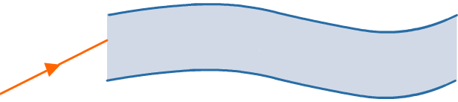

4. Describe the relationship between diffraction, wavelength and the size of the gap. When does the most diffraction occur?

…………………………………………………………………………..…………………………………
…………………………………………………………………………..…………………………………
…………………………………………………………………………..…………………………………
………………………………………..……………………………………………………………………
…………………………………………………………………………..…………………………………
…………………………………………………………………………..…………………………………

5. Why do astronomical telescopes have large apertures?

…………………………………………………………………………..…………………………………
…………………………………………………………………………..…………………………………
…………………………………………………………………………..…………………………………
………………………………………..……………………………………………………………………
…………………………………………………………………………..…………………………………
…………………………………………………………………………..…………………………………

6. Fill in the gaps in the sentences below.

When white light is incident on a glass prism it is ……………………. into the spectral colours. The light is refracted ……………………. the normal when it slows down as it enters the prism. The degree the light is refracted by depends on the …………………….. The shorter the ……………………., the more the light bends. ……………………. light is refracted the least and ……………………. light is refracted the most. At the second interface, the angle of the prism means that the light is dispersed further as it bends ……………………. the normal.

7. The diagram below shows a top-down view of an experiment with a monochromatic light source.
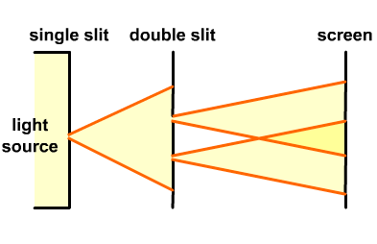
In the box below, draw what would be observed on the screen. Label areas of constructive and destructive interference.

screen

8. List three characteristics of coherent sources of waves:

1) ………………………………………..……………………………………………………………
2) ………………………………………..……………………………………………………………
3) ………………………………………..……………………………………………………………
9. Complete the table to show how electromagnetic waves with different frequencies behave in the atmosphere.

frequency | behaviour in atmosphere
below 30 MHz
30 MHz – 30 GHz
above 30 GHz

10. Why do satellite transmitting and receiving dishes need careful alignment?

…………………………………………………………………………..…………………………………
…………………………………………………………………………..…………………………………
…………………………………………………………………………..…………………………………
………………………………………..……………………………………………………………………

