Wave Properties Worksheet
This worksheet accompanies slide 27 of Wave Properties.ppt

- Complete the following sentences.
Waves travel as either longitudinal or …………………… waves.

The maximum disturbance of a point on the wave is called the…………………… .

Waves carry …………………… from one place to another.

The distance between two matching points on a wave is called the …………………… .

The …………………… of a wave is defined as the number of waves per second and
is measured in hertz (Hz).

A point of maximum amplitude is called the …………………… , and a point of minimum amplitude is called the …………………… .

- The image below shows a sound wave from a signal generator and loudspeaker ‘viewed’ by connecting a microphone to a cathode ray oscilloscope.

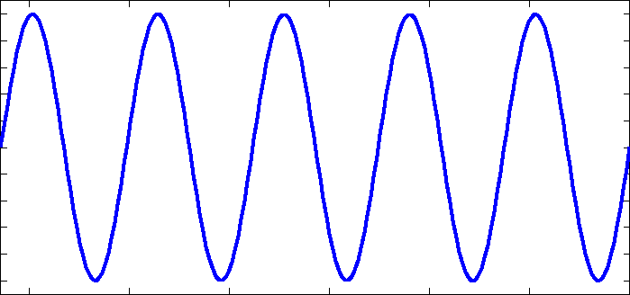

On the following diagrams, draw what you would expect to see if the sounds were:

a. quieter b. higher pitched c. made by a violin

