Volume, Pressure and Temperature Worksheet
This worksheet accompanies Volume Pressure and Temperature.ppt

1. Describe the difference between solids, liquids and gases in terms of how particles move.

…………………………………………………………………………………………………………………………
…………………………………………………………………………………………………………………………
…………………………………………………………………………………………………………………………
…………………………………………………………………………………………………………………………
…………………………………………………………………………………………………………………………

2. Complete the following table comparing temperatures in Kelvin and degrees Celsius.
Kelvin (K) | degrees Celsius (°C)
0
 | 0
 | 100
450

3. Calculate the force applied to the hydraulic jack shown below if the area of piston A is 0.1 m², the area of piston B is 2 m², and the force produced at piston B is 10 N.
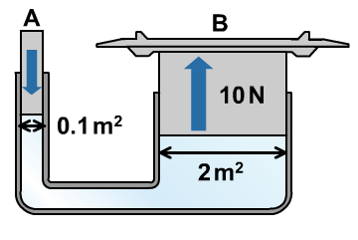

…………………………………………………………………………………………………………………………
…………………………………………………………………………………………………………………………
…………………………………………………………………………………………………………………………
…………………………………………………………………………………………………………………………

4. Write down two ways to increase the pressure of a gas.

i. …………………………………………………………………………………………………………………
…………………………………………………………………………………………………………………ii. …………………………………………………………………………………………………………………
…………………………………………………………………………………………………………………

5. Write down an equation linking pressure and volume and use it to explain why gases are stored at high pressures.

…………………………………………………………………………………………………………………………
…………………………………………………………………………………………………………………………
…………………………………………………………………………………………………………………………
…………………………………………………………………………………………………………………………
…………………………………………………………………………………………………………………………

6. A gas in a container has a pressure of 180,000 Pa and a volume of 0.05 m³. It has an initial temperature of 350 K. If it is heated to 450 K in the same container, calculate the new pressure.

…………………………………………………………………………………………………………………………
…………………………………………………………………………………………………………………………
…………………………………………………………………………………………………………………………
…………………………………………………………………………………………………………………………
…………………………………………………………………………………………………………………………

7. Write down the combined gas equation.

8. A cylinder contains a gas of volume 0.3 m³, at a pressure of 110 kPa and a temperature of 420 K. Find the temperature of the gas which has a volume 0.4 m³ at a pressure of 120 kPa.

…………………………………………………………………………………………………………………………
…………………………………………………………………………………………………………………………
…………………………………………………………………………………………………………………………
…………………………………………………………………………………………………………………………
…………………………………………………………………………………………………………………………

9. A protostar is formed when gravity makes a cloud of gas collapse. What happens to the pressure, volume and temperature?

…………………………………………………………………………………………………………………………
…………………………………………………………………………………………………………………………
…………………………………………………………………………………………………………………………
…………………………………………………………………………………………………………………………
…………………………………………………………………………………………………………………………
…………………………………………………………………………………………………………………………

