Ultraviolet Radiation Worksheet
This worksheet accompanies slide 18 of Ultraviolet Radiation.ppt

1. Use the virtual experiment results testing different sunscreens to plot a graph of SPF (on the x-axis) against the amount of UV passing through the sunscreen (on the
y-axis). Ensure you use a suitable scale, add labels, units and a suitable title.

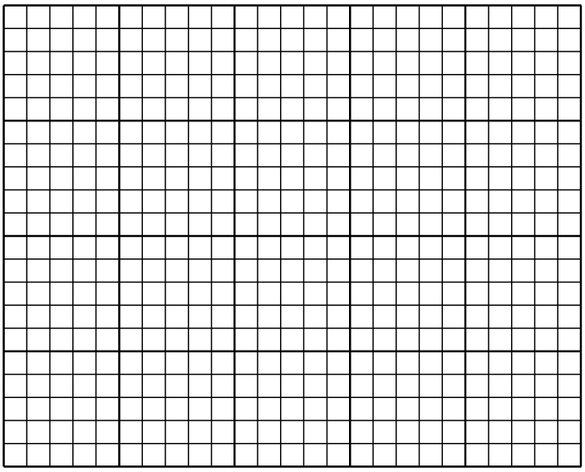

2. Explain the relationship between SPF and the amount of UV passing through.

…………………………………………………………………………………………………………………………………………………………………………………………………………………………………………………………………………………………………………………………………………………………………………………………………………………………………………
…………………………………………………………………………………………………………

3. Describe how wearing sunscreen allows us to stay out in the sun for a longer amount of time, using the experimental results.

…………………………………………………………………………………………………………………………………………………………………………………………………………………………………………………………………………………………………………………………………………………………………………………………………………………………………………
……………………………………………………………………………………………………………………………………………………………………………………………………………………

4. Apart from SPF and sun index what else might affect the amount of time a person can spend in the sun?

…………………………………………………………………………………………………………………………………………………………………………………………………………………………………………………………………………………………………………………………………………………………………………………………………………………………………………
……………………………………………………………………………………………………………………………………………………………………………………………………………………

